Shiskine Golf & Tennis Club
Blackwaterfoot
Isle of Arran
KA27 8HA

Job No: DB220722

Doug Bates Hydrogeological Prep: August 2022
Phil Langdon Survey Date: 30th September 2022

GRID REF: NR 89200 28540

GEODIVINING GROUNDWATER SURVEY of SHISKINE GOLF CLUB & AREA For PERENNIAL WATER SUPPLY for GOLF COURSE IRRIGATION

INTRODUCTION:

Thank you for your interest in a Geodivining Survey to locate and assess the best accessible groundwater source for drilling a water supply borehole on your property.


The accompanying Guide documents provide detailed background information about the varied geology of Scotland and other regions, and the very variable occurrence of groundwater in different rock formations, in which, generally, the high yield groundwater flows are confined to narrow vertically oriented faults and fracture zones, which can be accurately mapped by unique Geodivining survey methods to the extent of almost certain optimal intersection of these water-bearing structures by exactly positioned boreholes.

The current guide is: ‘GUIDE TO GEODIVINING GROUNDWATER SURVEYS
– SURVEY & PROJECT MANAGEMENT –
This guide provides all the information you need to know about commissioning a Geodivining Survey and what to expect from it, with a variety of relevant case studies. We are currently working on a series of Regional Geology Guides based on the geologically defined regions or ‘geological provinces’ of Scotland and other regions; and the most relevant guide or guides may be included with your final survey report.

A second guide is: GEODIVINING GROUNDWATER SURVEYS; Principles and Substantiation:
20 years in unconventional exploration - January 2014 - with 2017 update
This guide provides more detailed discussion on Geodivining Survey methodology relative to conventional Geophysics and focuses on the successful and highly goal-oriented troubleshooting work that we frequently do, where we are required to find substantial water supplies in places where previous drilling attempts have failed to find any or to find enough. This demonstrates very clearly, through numerous examples, the efficacy and economic value of our unconventional Geodivining Survey work, and how this is most likely to achieve successful and economical results for you as well.

SURVEY BRIEF:

The proposed Geodivining Groundwater Survey covers the whole area of the property and environs up to a catchment estimated to be of sufficient size to provide sustainable yield for the water supply required; to map any superficial aquifers and detect high-yield structural aquifers in the underlying bedrock, thus determining the best exact optimum drilling locations to develop the required water supply successfully, from one or a specified number of boreholes, based on pre-assessment of the geological setting.

1 | Property Area (hectares) | > 30
2 | Total Survey Area (hectares) | > 50
3 | Type of Water Supply Required - | Golf course irrigation
4 | Minimum Daily Water Requirement (m³/day) | 400m³/day
5 | Minimum Hourly Water Requirement (litres per hour) | 18,000 l/hr
6 | Ideal Hourly Water Supply Target (litres per hour) | > 20,000 l/hr (up to 480m³/day)
7 | Water Quality Specification | Good clear groundwater
8 | Range of achievable yields per borehole (litres per hour) | 1,000 to 50,000
9 | Likely number of Boreholes needed to achieve MDWR | 2 (85% probability), perhaps 3

SURVEY AND FOLLOW-UP SERVICES AGREED FROM THE SURVEY PROPOSAL:

Based on the current Survey Guide, this is an Agricultural Category Level 6 survey for up to 500m³/day.

The appropriate fee was agreed with 2iC.

 | DESCRIPTION OF SERVICE | NEW | TROUBLESHOOT
1 | Basic Geodivining Survey | Yes
2 | Basic Survey Report | Yes
3 | Full Survey Report | Recommended
4 | Project Management & Borehole Logging Service | Recommended
5 | Drilling and Testing Report | Recommended
6 | SEPA Compliance (Borehole Registration) | Required
7 | SEPA Compliance (Water Features Survey) | Required
8 | SEPA Compliance (Abstraction License) | Required
9 | SEPA Compliance (Environmental Impact Assessment) | n/a
10 | SEPA Compliance (Flood Risk Assessment) | n/a

PREPARATORY MAPS AND GEOLOGICAL RESEARCH:

The following maps and research notes provided a hydrogeological pre-assessment for your survey, which formed the basis of survey expectations and the subsequent ‘Basic Survey Report’ giving details of all selected drilling locations, expected depth and yield, and a basic drilling specification.

In most cases we will have more detailed maps and research collated for reference during the site survey and these may be incorporated into a more detailed ‘Full Survey Report’ (if commissioned), including details of environmental compliance criteria, drilling and testing results, and assessment of water quality results.

LOCATION MAPS: NGR = NR 89200 28540

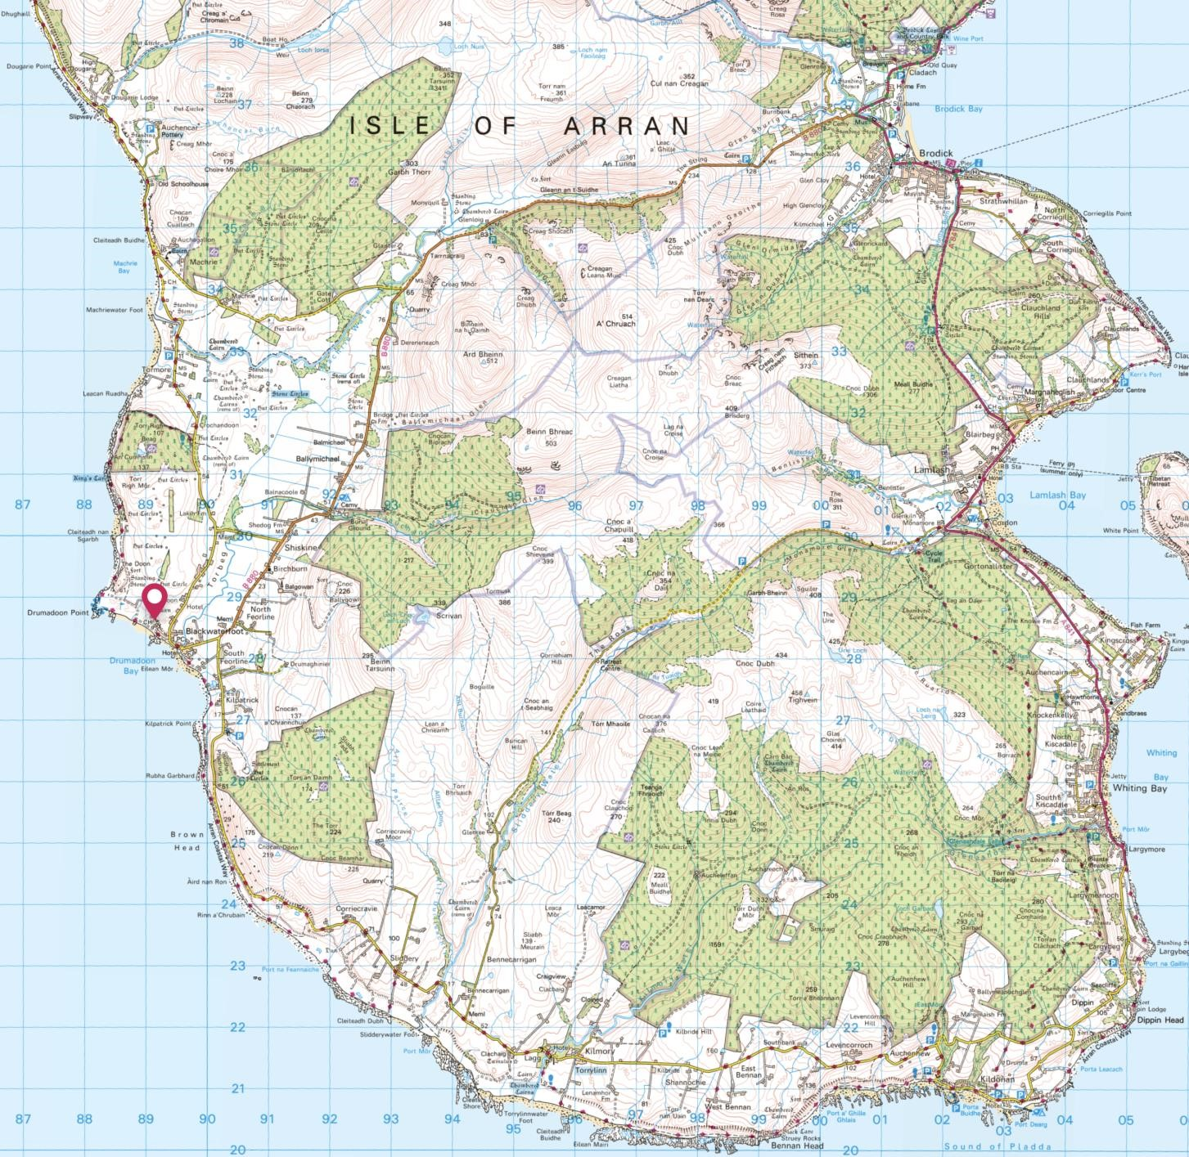
1:50,000
Ordnance Survey Map

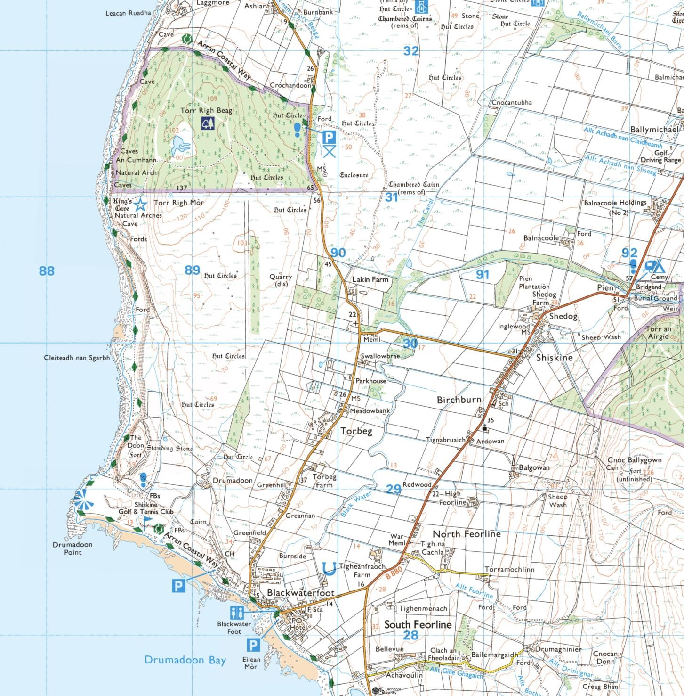
1:25
,000 Ordnance Survey Map

1:12,500 Ordnance Survey Map

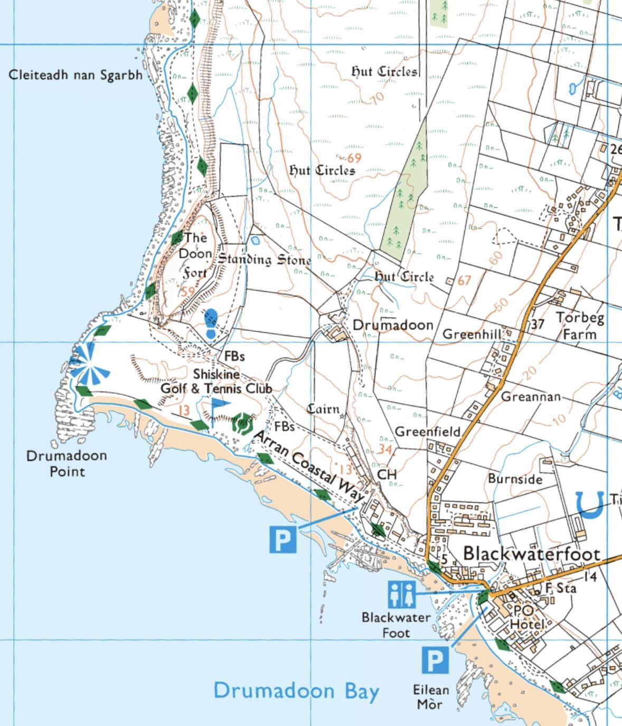

GEOMORPHOLOGY AND DRIFT GEOLOGY:

The terrain of Arran is strongly determined by the variations of the bedrock geology with the high peaks of north Arran consisting entirely of the Arran granite pluton with its surrounding jacket of intensely folded and altered metamorphic rocks uplifted with the granite, and a complex mix of sedimentary and igneous rocks across the southern half of the island.

Superficial cover (subsoil or ‘drift’) consists primarily of boulder clay (shaded pale blue) and glacial till/moraine deposits (shaded green), littered with numerous large boulders of granite, some alluvial sand and gravel (shaded yellow and pink) and raised beach deposits (orange) are found in low-lying areas along the coast.
These deposits are significant in the context of casing depth and in their retentive and transmissive properties in relation to rainfall infiltration and groundwater protection.

Map Extract from BGS 1:50,000 Series, Scotland Sheet Arran, Drift (1985).
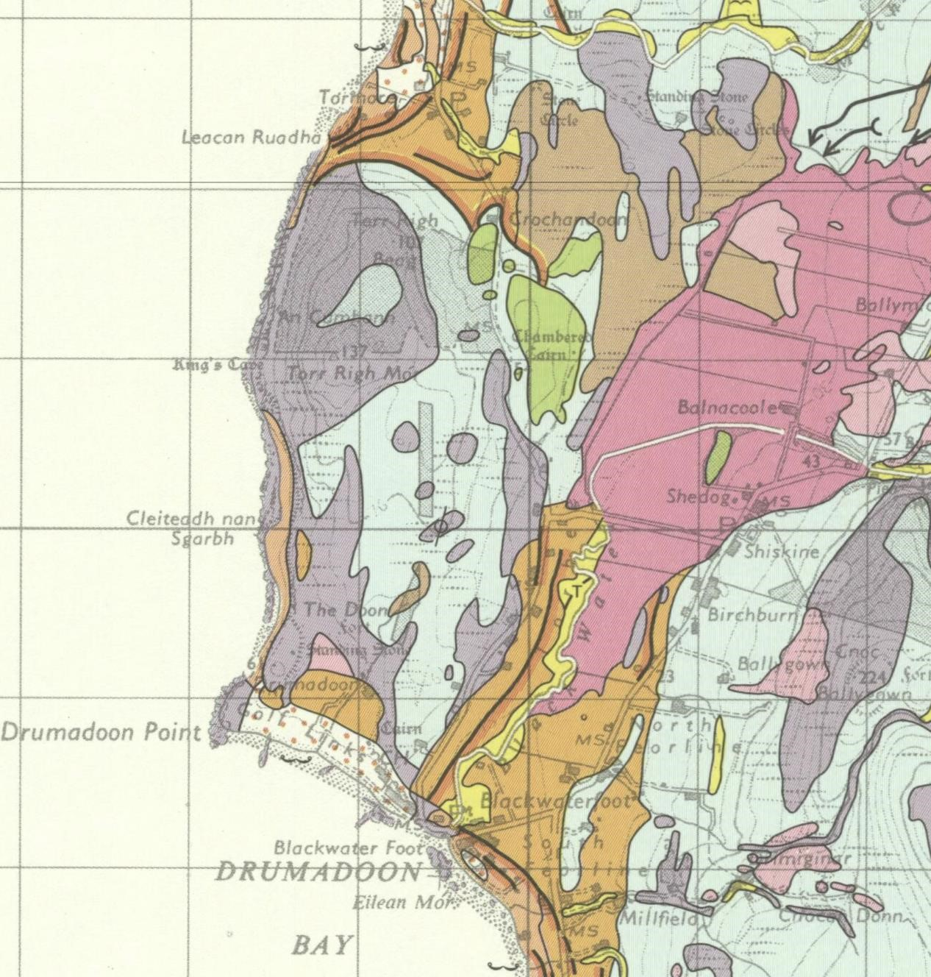

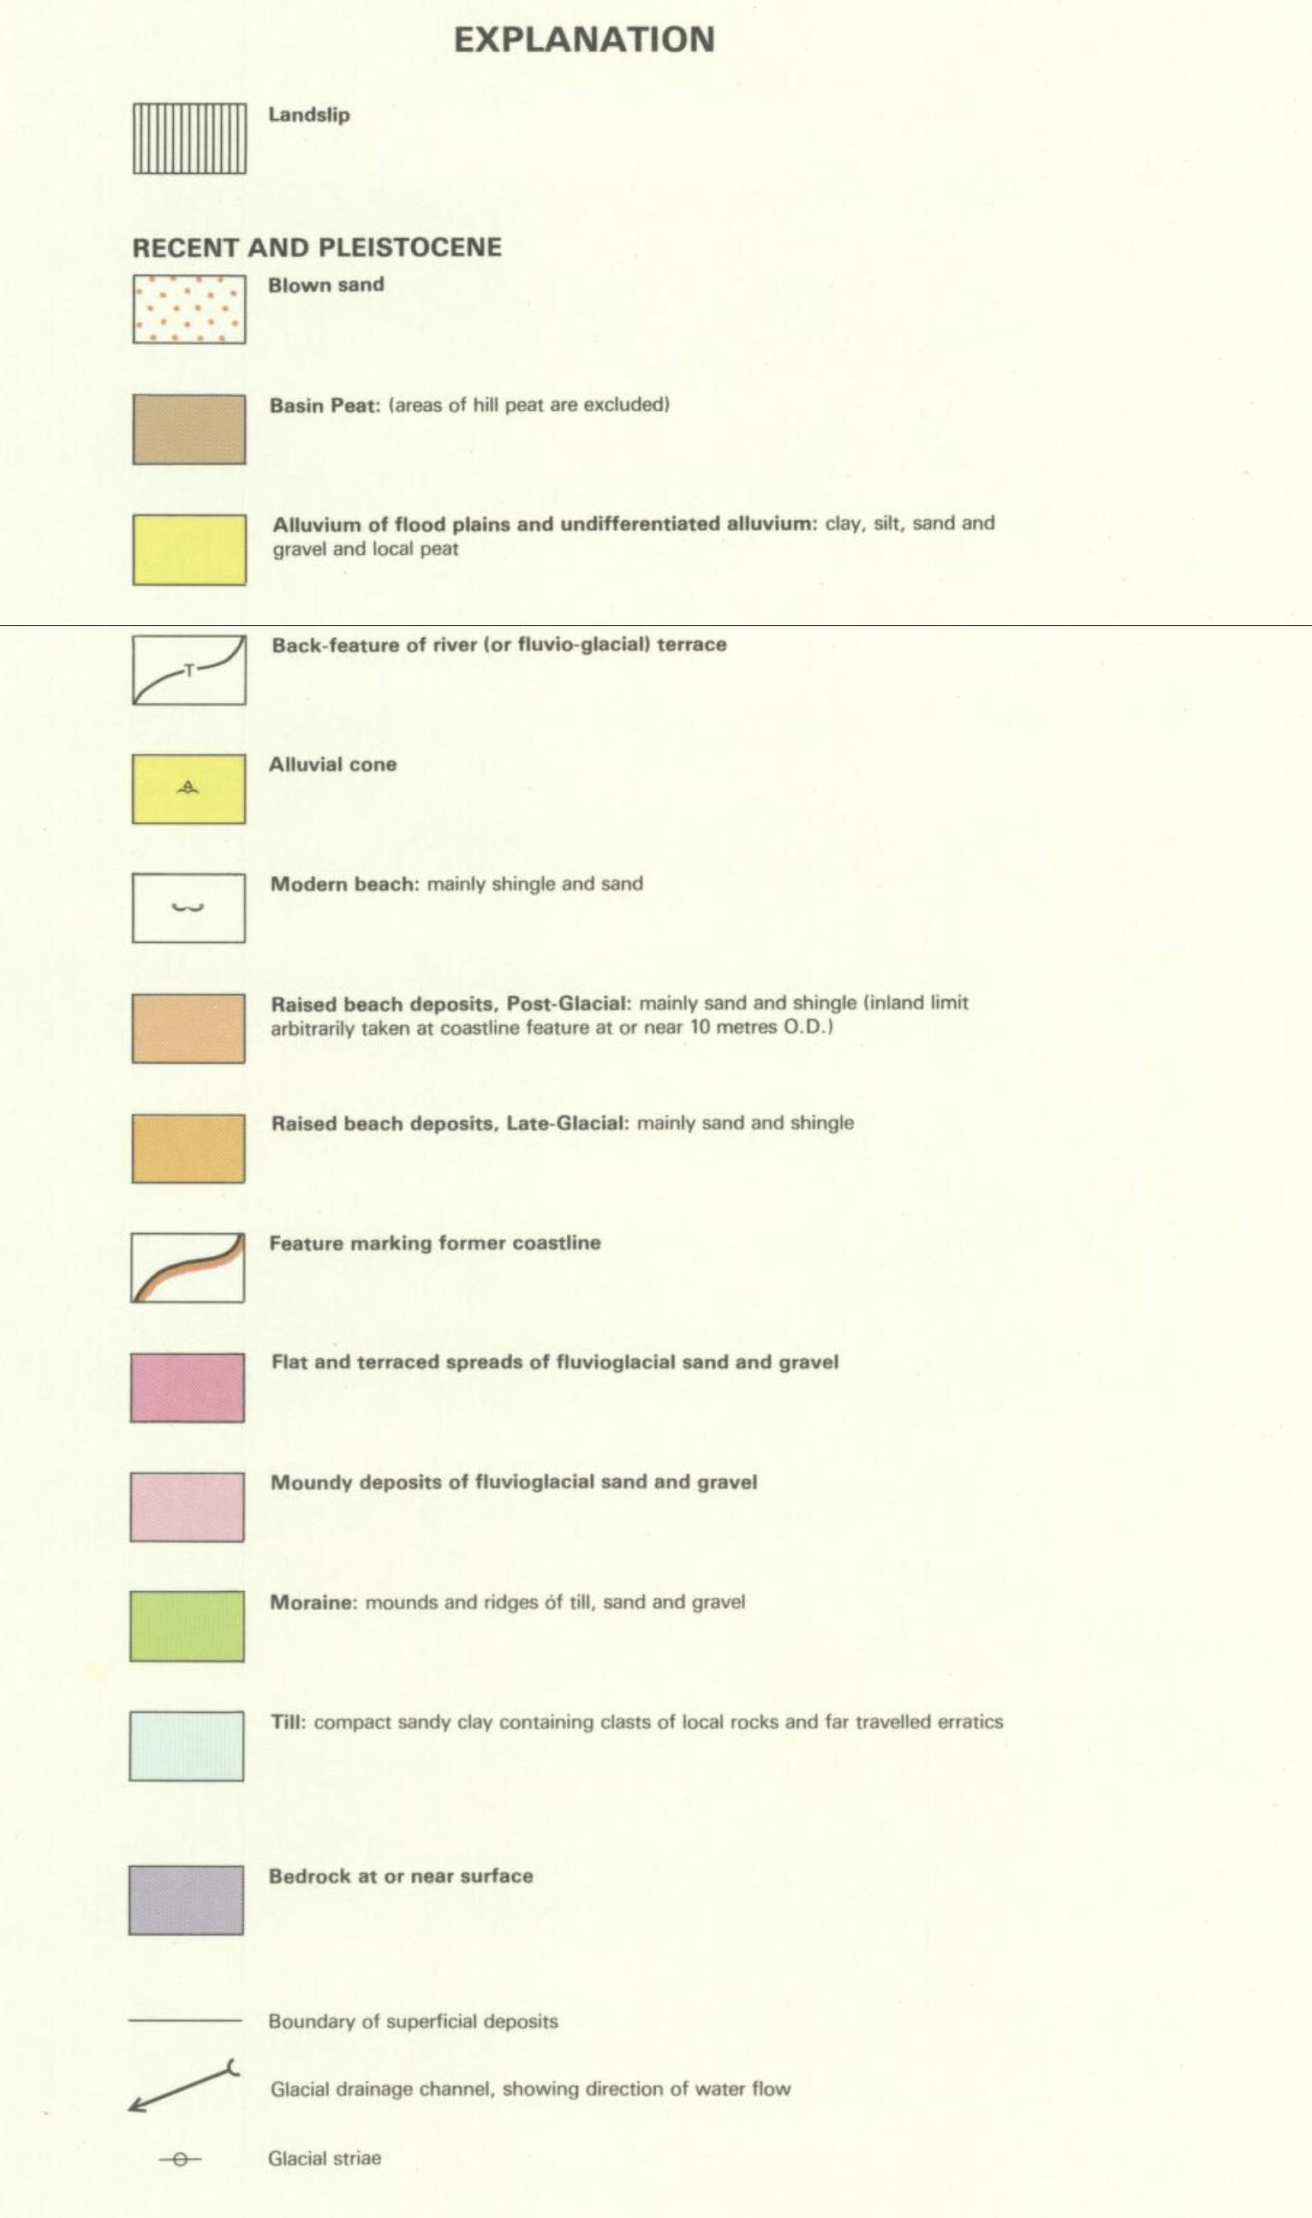

BEDROCK GEOLOGY:

The terrain of Arran is strongly determined by the variations of the bedrock geology with the high peaks of north Arran consisting entirely of the Arran granite pluton with its surrounding jacket of intensely folded and altered metamorphic rocks uplifted with the granite, and a complex mix of sedimentary and igneous rocks across the southern half of the island.
Details from the Geological Mapping of the area (below) show that there are sharp, mostly faulted transitions between the uplifted jacket of deformed Precambrian metamorphic rocks (shaded mustard) surrounding the Arran granite (red) and subsided sedimentary rocks to the south (various brown shades). These rocks are extensively faulted and fractured due to several phases of tectonic activity in the geological history of the region, most significantly, the major disruption that occurred at the time of volcanic eruptions on Arran starting with basaltic lavas about 66 million years ago, followed by the intrusion of the Arran granite about 54 million years ago, and numerous late-phase basic dykes and sills (marked as green or orange narrow vertical strips or broader sub-horizontal layers, labelled K^{A}, K^{D}, K^{T}, FV, qF^{P}, Q^{D}, etc)...

Map Extracts from BGS 1:50,000 Series, Scotland Sheet Arran, Solid (1987).

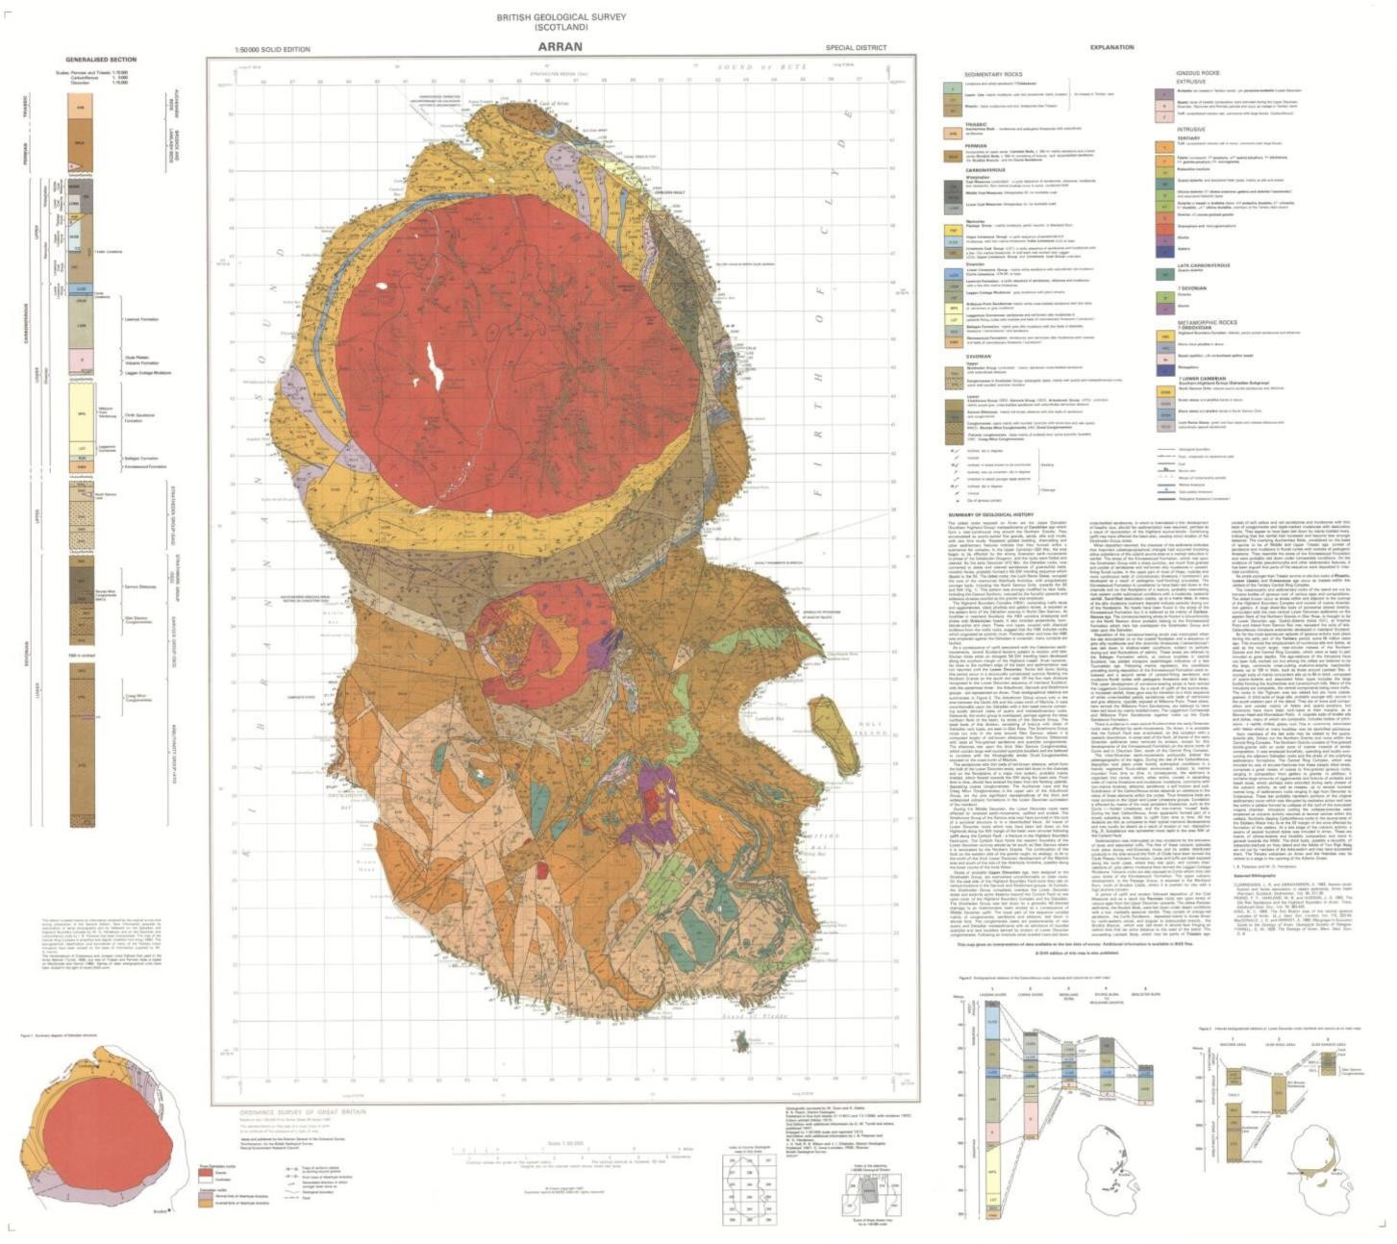

The classic Tertiary Volcanic Centres of Western Scotland, namely the Isle of Arran, the Isle of Mull, the Ardnamurchan peninsula, Rum, and the Isle of Skye, attract geology teachers and students from all over the world to study their complex structures and lithologies. They represent the last phase of volcanic activity in Scotland prior to the northward extension of sea floor spreading and the opening of the North Atlantic Ocean.
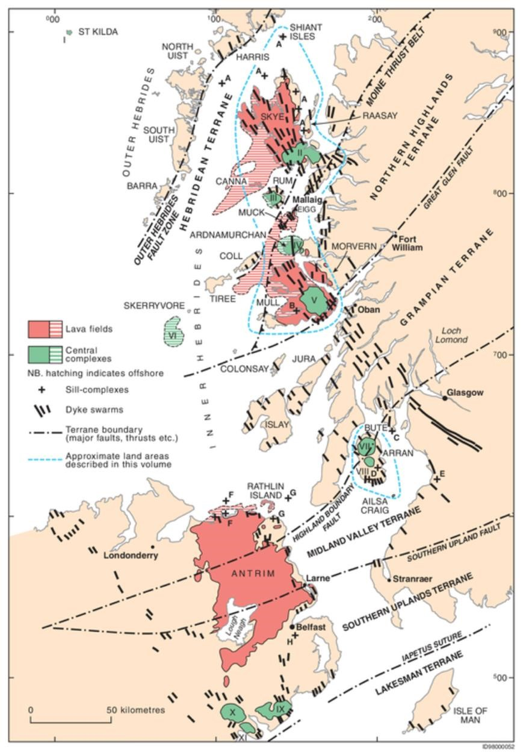
There is an extensive and fascinating literature on this subject, some of which explores the possible tectonic origins of these eruptions, which are curiously aligned along a deep-seated SSE-NNW trend that extends from the Irish Sea through the Hebrides to the Faroe Islands, Iceland and southern parts of Greenland, and cuts across all older fault and rift valley structures in the region.

The era-ending global shock from the Chicxulub bolide impact on the Yucatan peninsula (which was closer to Scotland 66 million years ago than it is now) is recognised as the trigger for enormous outbreaks of volcanic activity around the globe and especially here in the North Atlantic Igneous Province, where activity continues to t his day in Iceland.

Palaeogene central complexes, lava fields, sill complexes and dyke swarms in western Scotland and Northern Ireland. From Emelius, C H, and Bell, B R, 2005. British Regional Geology: The Palaeogene volcanic districts of Scotland. Fourth edition. Keyworth, Nottingham: British Geological Survey.

These eruptions began with massive outpourings of basaltic lavas from hundreds of fissure
eruptions, the evidence of which is preserved in swarms of intrusive dykes and large basic lava fields across Northern Ireland and the Hebridean region, followed by later phases of intermediate and acid igneous intrusions beneath major volcanic centres that developed at weak points on much older SW-NE trending terrane boundaries… Slieve Gullion and the Mountains of Mourne on the Iapetus Suture zone, Arran on the Highland Boundary Fault, Mull on the Great Glen Fault, and Ardnamurchan, Rum and Skye on major faults in the Moine Thrust zone.

On Arran there is nothing left of any basalt lavas, which were rapidly removed by uplift and erosion, especially extensive glacial erosion in the Firth of Clyde during the most recent Pleistocene epoch, and what we see exposed today are the granitic plutons that formed at the root of the volcanoes and the variously uplifted and deformed metamorphic and sedimentary rocks through which the granites intruded.
Granitic magmas form by differentiation and fractionation as basic magmas evolve. High temperature fluid basic magmas rise towards the Earth’s surface rapidly and erupt first, leaving behind more viscous magma of increasingly acidic composition in evolving magma chambers that slowly cool and crystallise as they rise towards the surface forming large granitic plutons that, being less dense than most surrounding rocks, add buoyancy and uplift to regions of crust where they form. Some granites continue to push up through the surrounding rocks even after they have fully crystallised, and we see a good example of this in Arran.
The main granite pluton is about 12km in diameter and is sheathed in Precambrian metamorphic rocks of the Grampian Terrane from the foot-wall of the Highland Boundary Fault, which itself is distorted around the south side of the granite. The rocks are foliated and steeply inclined. To the south lies a thick series of Devonian, Carboniferous, Permian and Triassic sedimentary rocks broken into a chaotic mosaic of variously tilted blocks and wedges formed partly by deep subsidence within the original rift-valley environment of the Midland Valley Terrane and partly by the uplifting forces of the Tertiary volcanic eruptions and granite formations. A smaller volcanic vent and granite complex, 4km in diameter, is intruded into these sedimentary strata to the south of the main pluton, forming three 500+m hills to the southeast of the Machrie Water valley and the Brodick Shiskine road. In the Shiskine area, to the southwest of that volcanic vent, the youngest Permian and Triassic sedimentary rocks are down-faulted in a block that is hydrogeologically isolated by the Machriewaterfoot Fault on the north side and the Cnoc Ballygown Fault on the east side.
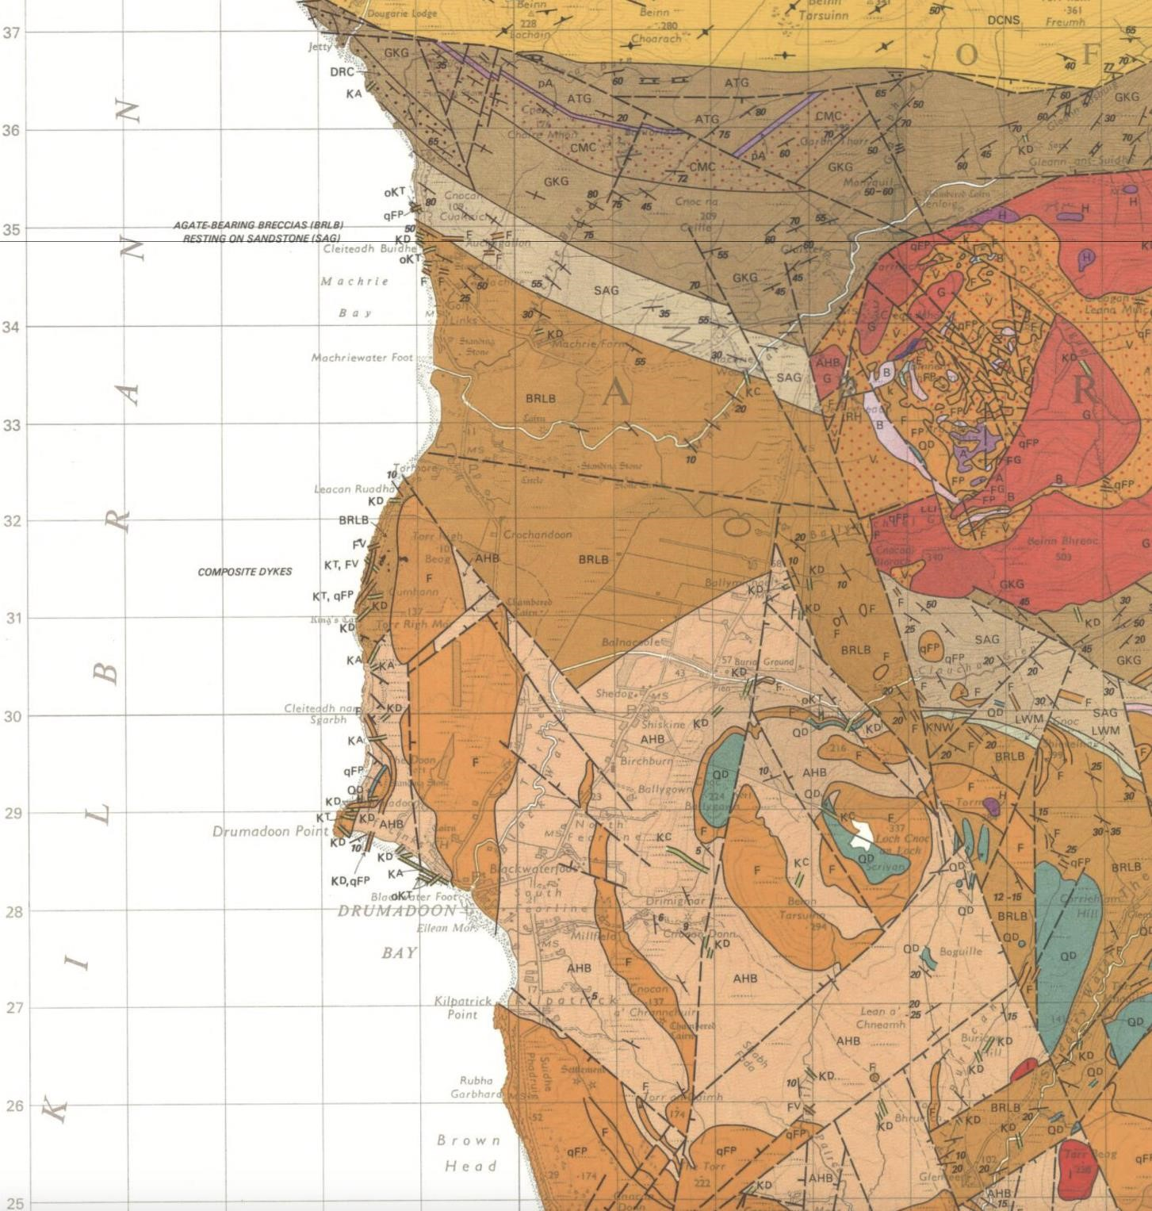

The strata within the Shiskine block are relatively flat lying, with gentle southerly to south-easterly inclinations in the northern part of the area and more easterly inclinations to the south of Shiskine.
These strata are intruded by a thick felsite sill and numerous small sills and dykes, all of Tertiary age. All the rocks within the block are broken by several local faults and fracture zones, showing that tectonic movements were taking place during and after the Tertiary eruptions.
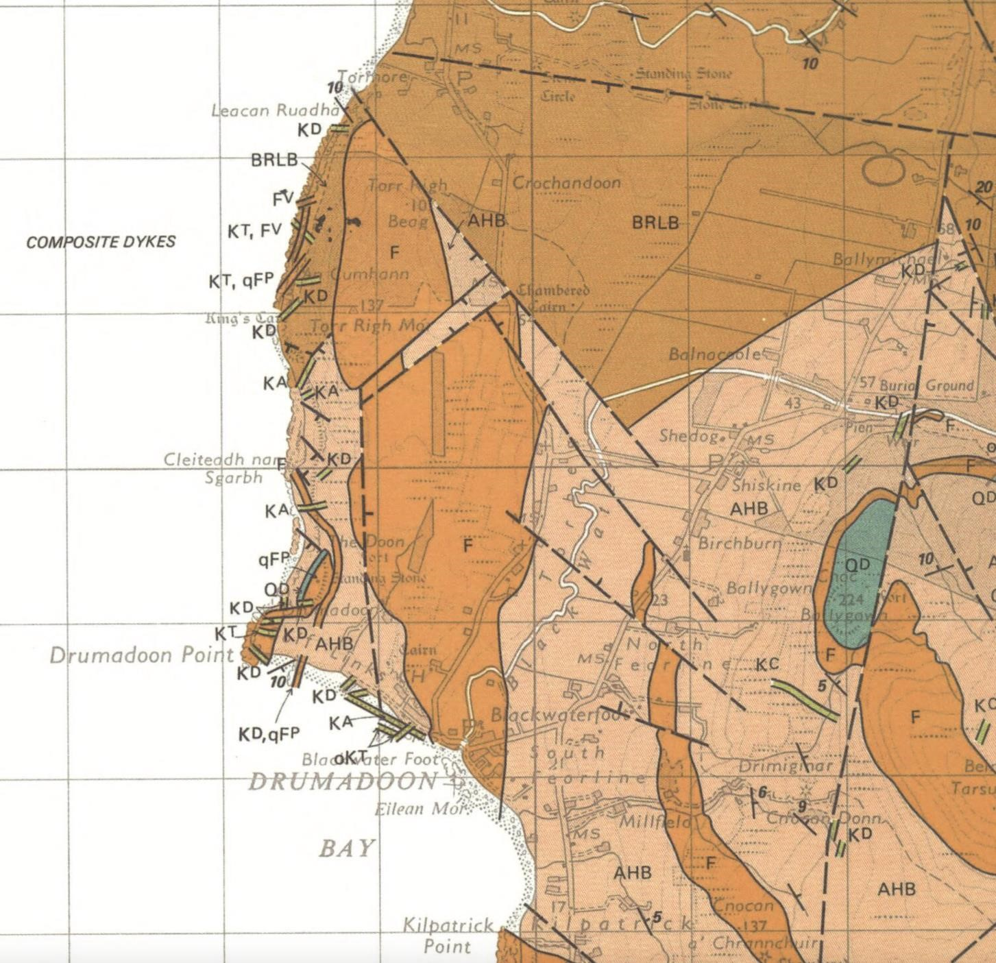

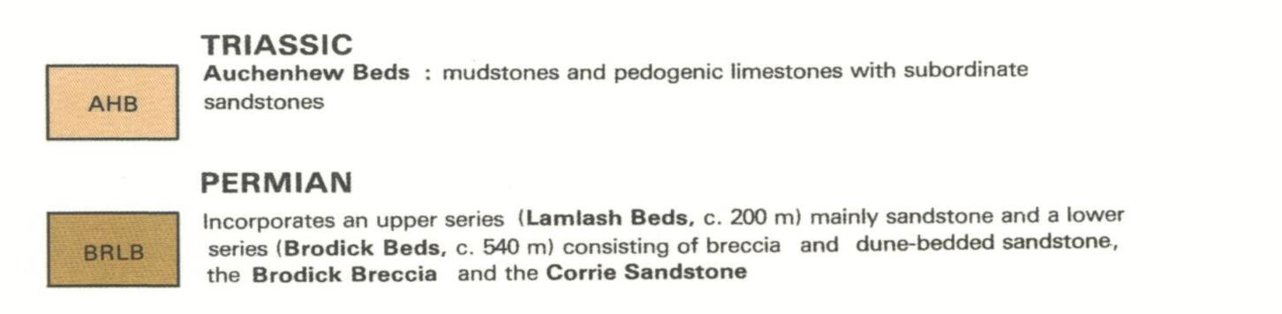
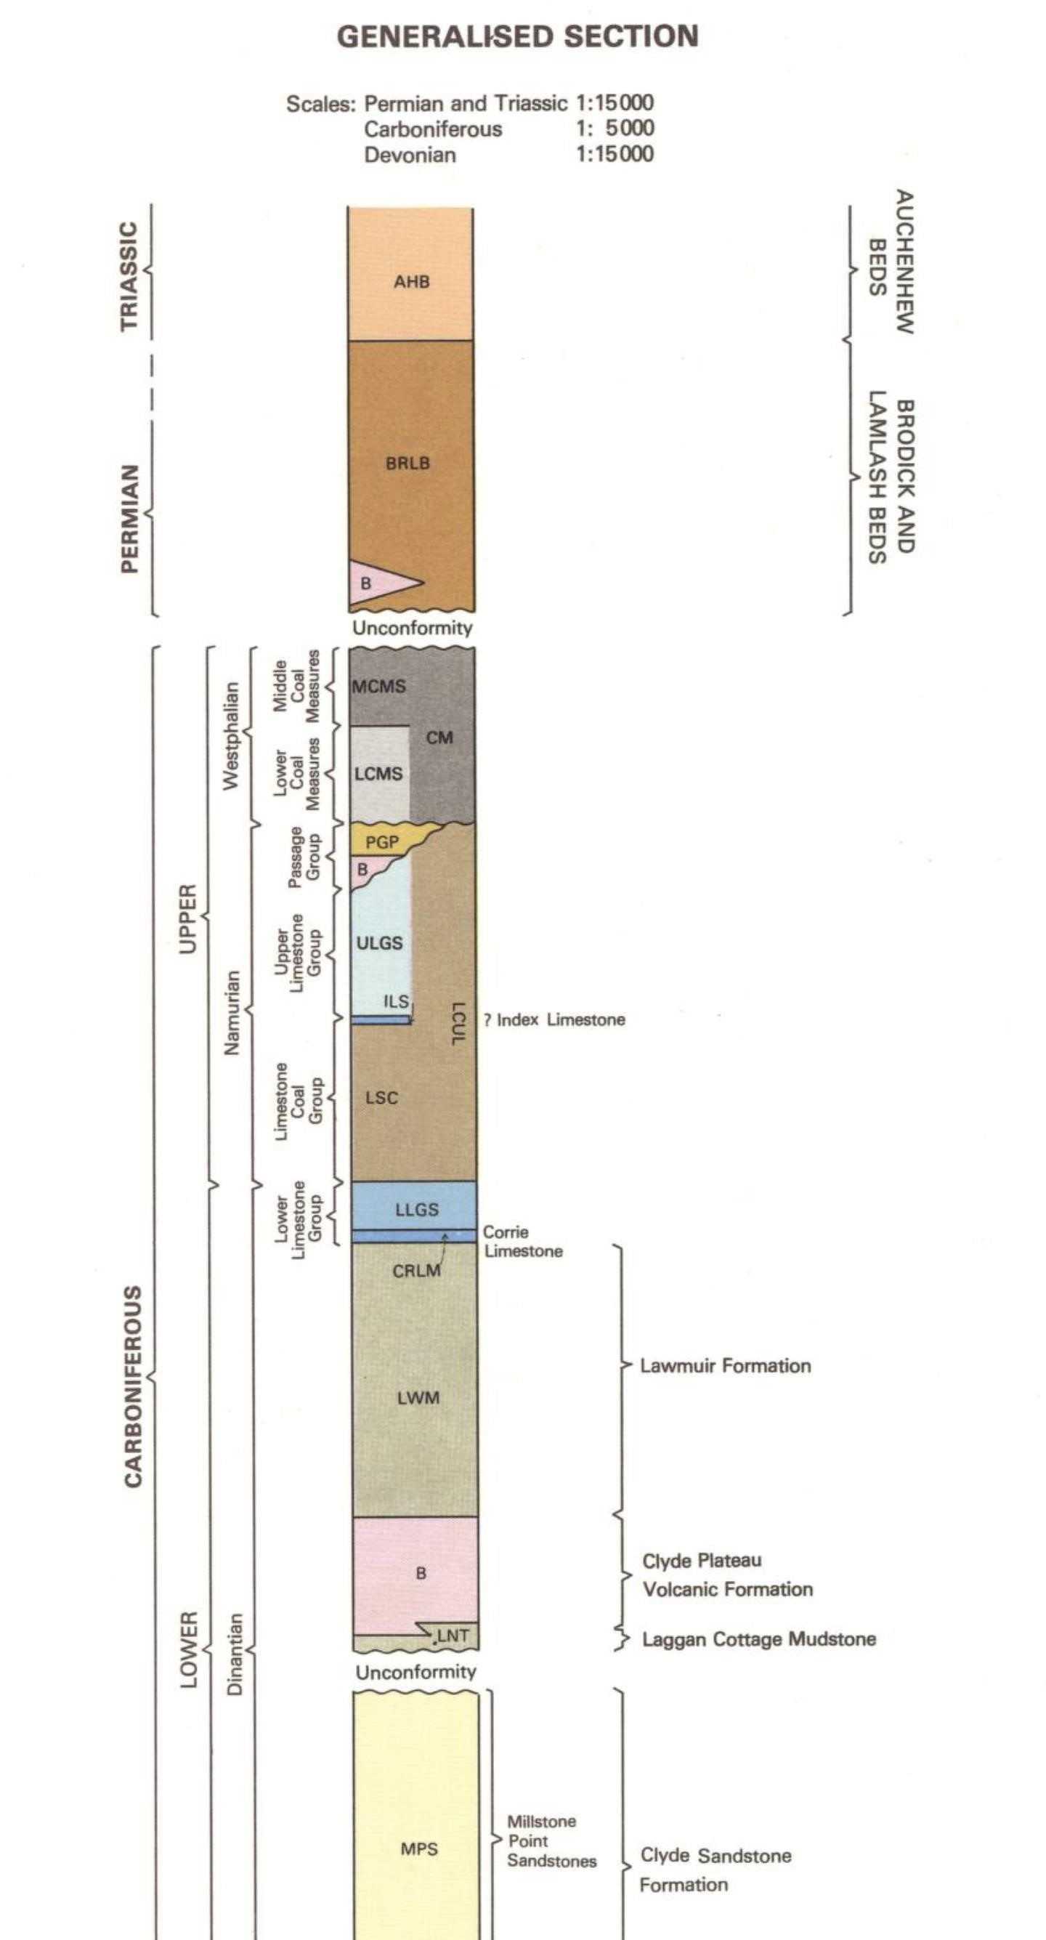
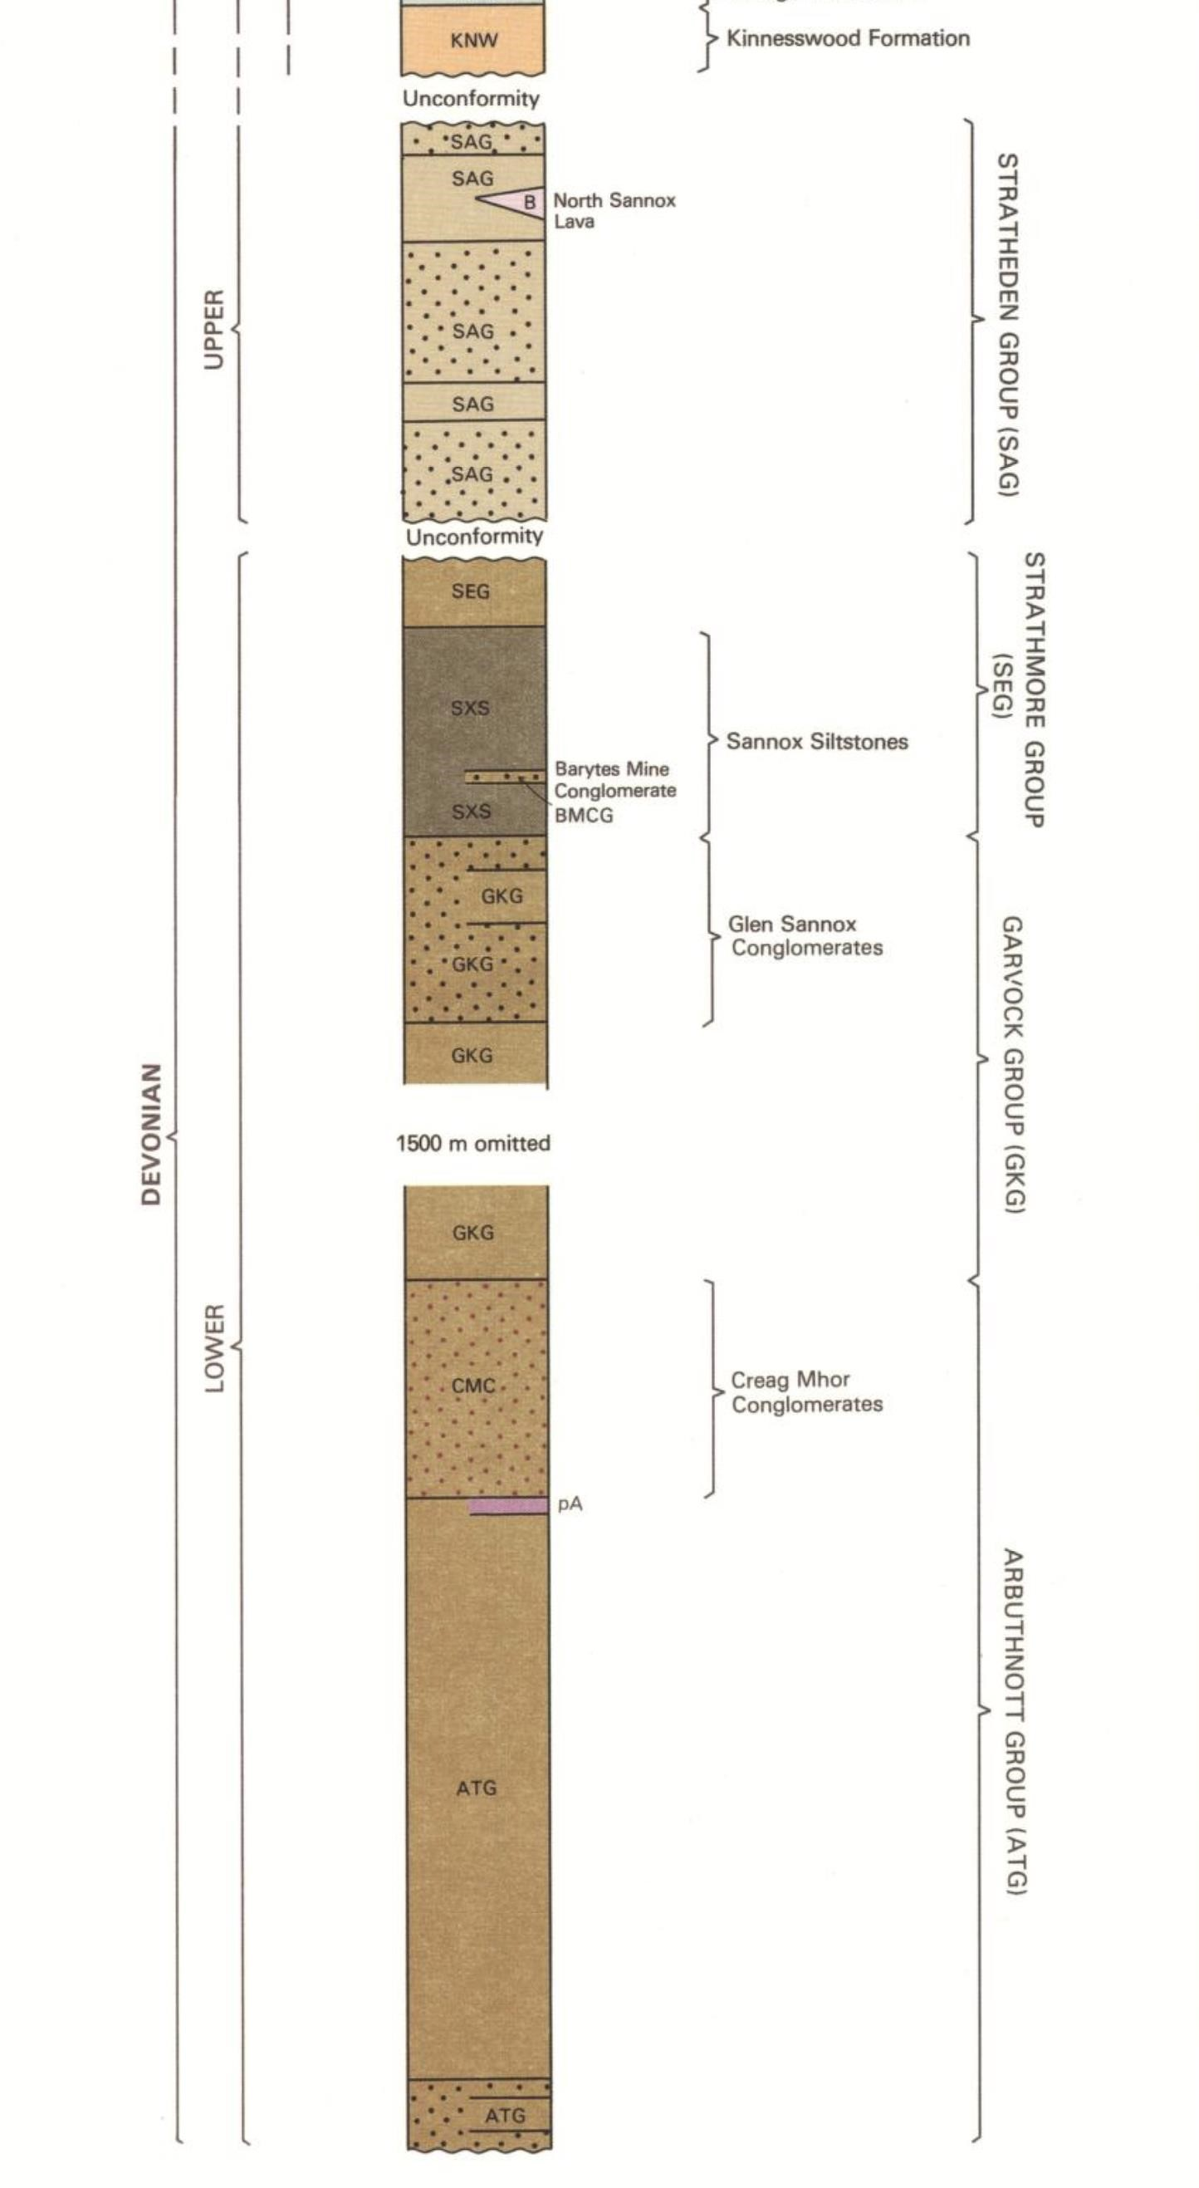

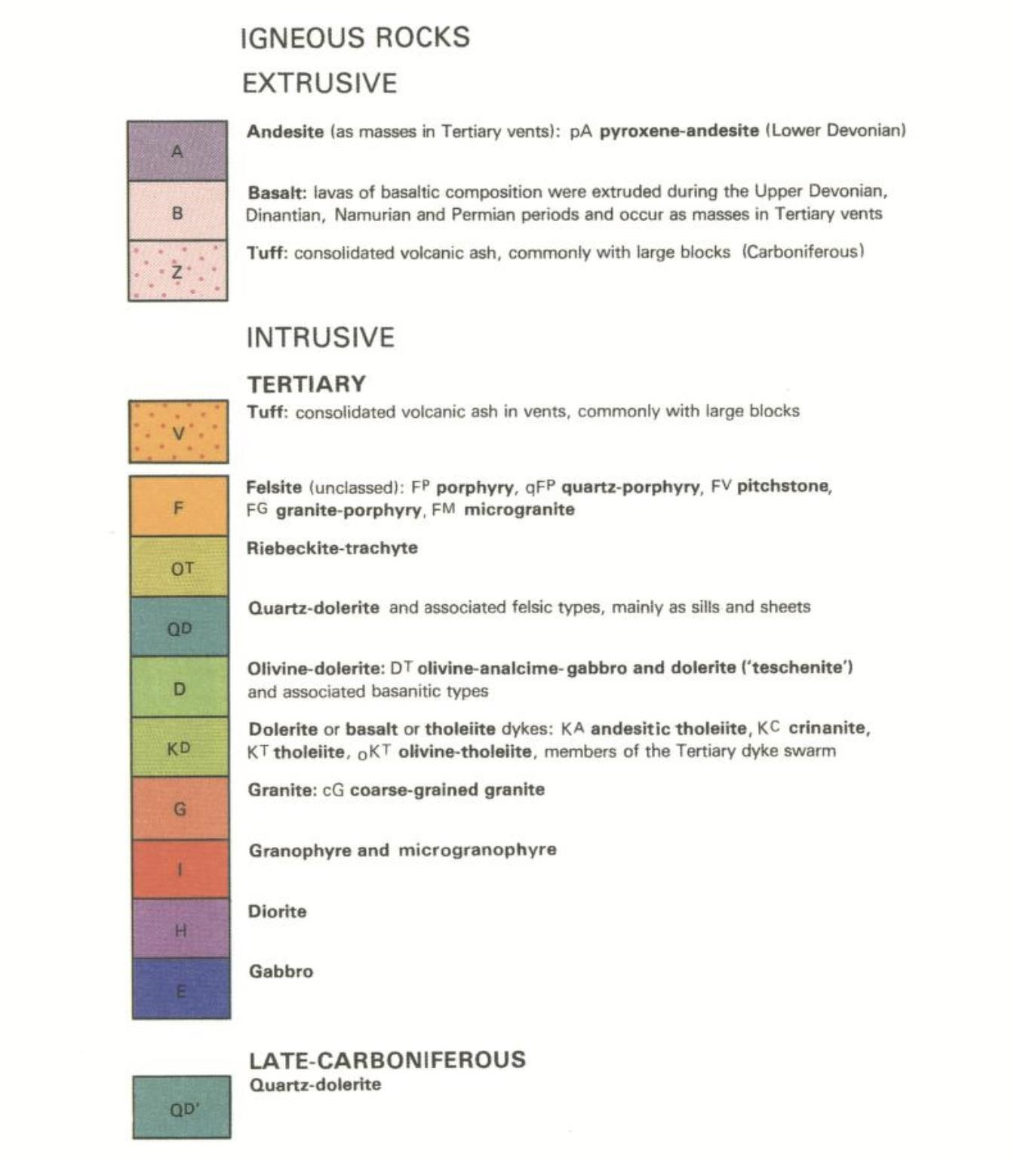

LOCAL HYDROGEOLOGY:

The Sedimentary strata are variably porous and permeable, but the igneous rocks are crystalline, non-porous, and impermeable except where they are fractured. The various bedrock formations described above are broken by faults (dashed lines) and fracture zones, which provide a variable degree of secondary permeability by which approximately 90% of actual groundwater flow in the area is transmitted.
These faults and fractures provide a network of deep conduits for relatively rapid groundwater flow drawing upon extensive volumes of variably permeable bedrock. Small local fractures drain to larger fracture zones and major faults, including intrusive dyke margins, where hydraulic conductivity can be up to 3 orders of magnitude higher than the low average for the overall rock mass. Accurate intersection of these structural aquifers can produce exceptional yields (see Survey Guides).

Groundwater catchment calculation: Rainwater infiltrates through the soil layer or directly into all these bedrock strata at very variable rates of about 25-250mm per year in Scotland, tending to flow preferentially along faults and fractured zones, especially along dykes, where the water flows easily through cracks in the rock rather than through the poorly permeable or impermeable rock medium.
Over southern Arran terrain the average infiltration rate is likely to be only 50-100mm per year, adding about 500-1000m³/year to groundwater, per hectare of land. A 400m³/day seasonal water supply amounts to about 40,000m³/year, requiring an effective catchment area of at least 80 hectares to sustain it.
Clearly there is more than enough land to sustain this quite modest water supply and if we can find exactly where to drill to get good intersection with the best interconnected fracture networks then there should be no problem with yield or sustainability. Some boreholes intersecting major faults or fracture zones effectively draw water from 100-500 hectares or more allowing potential borehole yields in excess of 400m³/day at carefully chosen locations.

Water quality is expected to be good to excellent, requiring minimal filtration.

Geodivining International specialises in accurately mapping faults and fracture zones in bedrock for direct intersection by drilling for relatively high yields and optimum borehole productivity.

Geodivining Survey methods are designed specifically for accurately detecting and assessing concealed deep water-bearing structures for directly targeted drilling at exactly selected locations, even in areas where the bedrock is completely covered. Details of the methodology and examples are provided in the accompanying guide documents.

We often discover faults that haven’t been mapped before and the findings from this survey reported in the next section will show examples of this with newly discovered faults that fit the geological context and actually improve the structural interpretation of the mapped geology.

High sustainable borehole yields depend on the intersection of extensive water-bearing fractures and where major faults or fracture zones are successfully intersected, in the south of Arran, yields up to 50,000 l/hr are achievable, though yields of 1,000 – 10,000 l/hr are more typical.

Drilling to develop such water sources affords the benefits of high productivity (less drilling for more water), optimal water supply quality and sustainability, and good economy both from the drilling and operational aspects. This is the primary objective of the Geodivining survey. Where an abundant supply is developed, of course, it also opens opportunities for other development or activity on the land for which a water supply would be needed.

THE GEODIVINING GROUNDWATER SURVEY REPORT:

THE REMOTE-SENSORY GEODIVINING SURVEY ON MAPS AND AERIAL IMAGES:

Please refer to the accompanying PDF guide documents for a detailed description of the goal-oriented Geodivining Survey methodology.

Brief Description of findings:
The remote-sensory work on the aerial image/s below shows distinct linear faults or fracture zones matching or exceeding a yield target of 20,000 l/hr, with subsidiary detail plotted for a lower target of 10,000 l/hr. This reveals more detail than the geological mapping of exposed features as drawn on the overview, with concealed water-bearing structures becoming apparent in the closer detailed work.
The uncertain North-South trending fault line plotted on the geological map resolves into a more complex combination of intersecting SW-NE and NW-SE trending faults, consistent with dominant faulting trends in the Shiskine area.

Water-bearing fracture zones with potential exceeding the minimum yield target and potentially exceeding the ideal yield target (delineated in blue) are revealed by the remote-sensory Geodivining survey; with the site survey target/s (circled in white) and exclusion zones around known sources of contamination (shaded purple).
Existing boreholes and other physical and geological features are marked and labelled.

Intersection Points that are clear of contamination risks, within reasonable range for power supply, and where both target levels give strong positional coincidence, indicative of good verticality and/or multiple fractures, are favoured targets (circled in white) for confirmation on the ground.

Exact Locations confirmed, staked and assessed on site are numbered and marked with white PVC pipes set firmly into the ground, and marked with small white circles in the aerial images.

AERIAL IMAGES SELECTED FOR THIS SURVEY: OVERVIEW
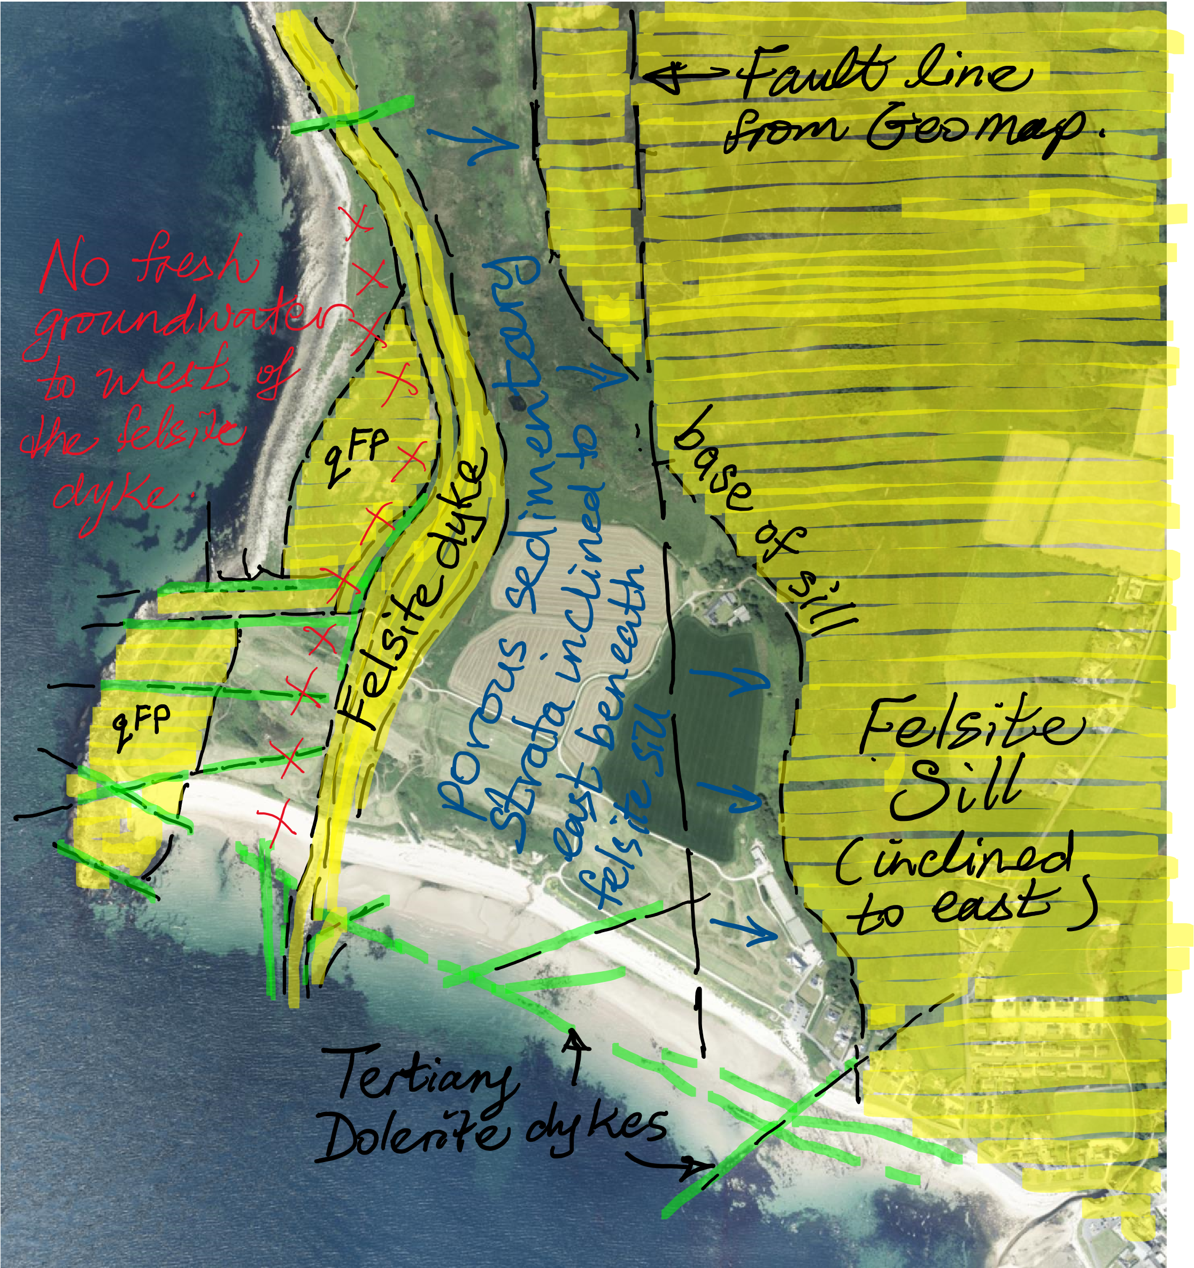

AERIAL IMAGES SELECTED FOR THIS SURVEY: WEST
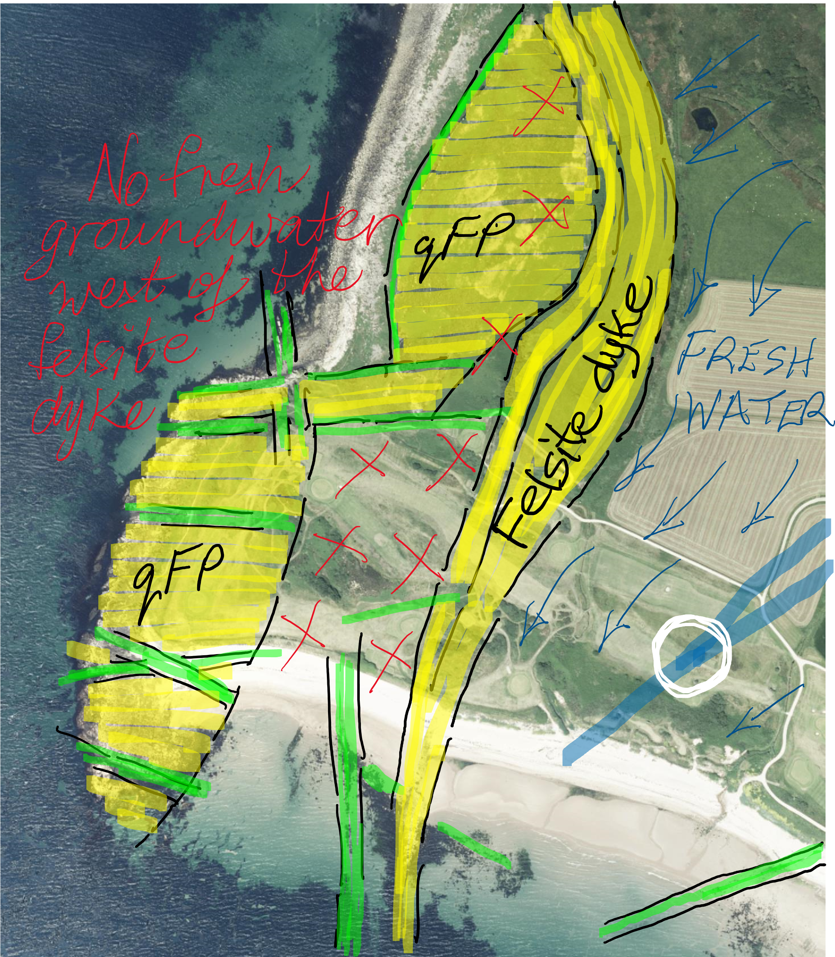

AERIAL IMAGES SELECTED FOR THIS SURVEY: EAST
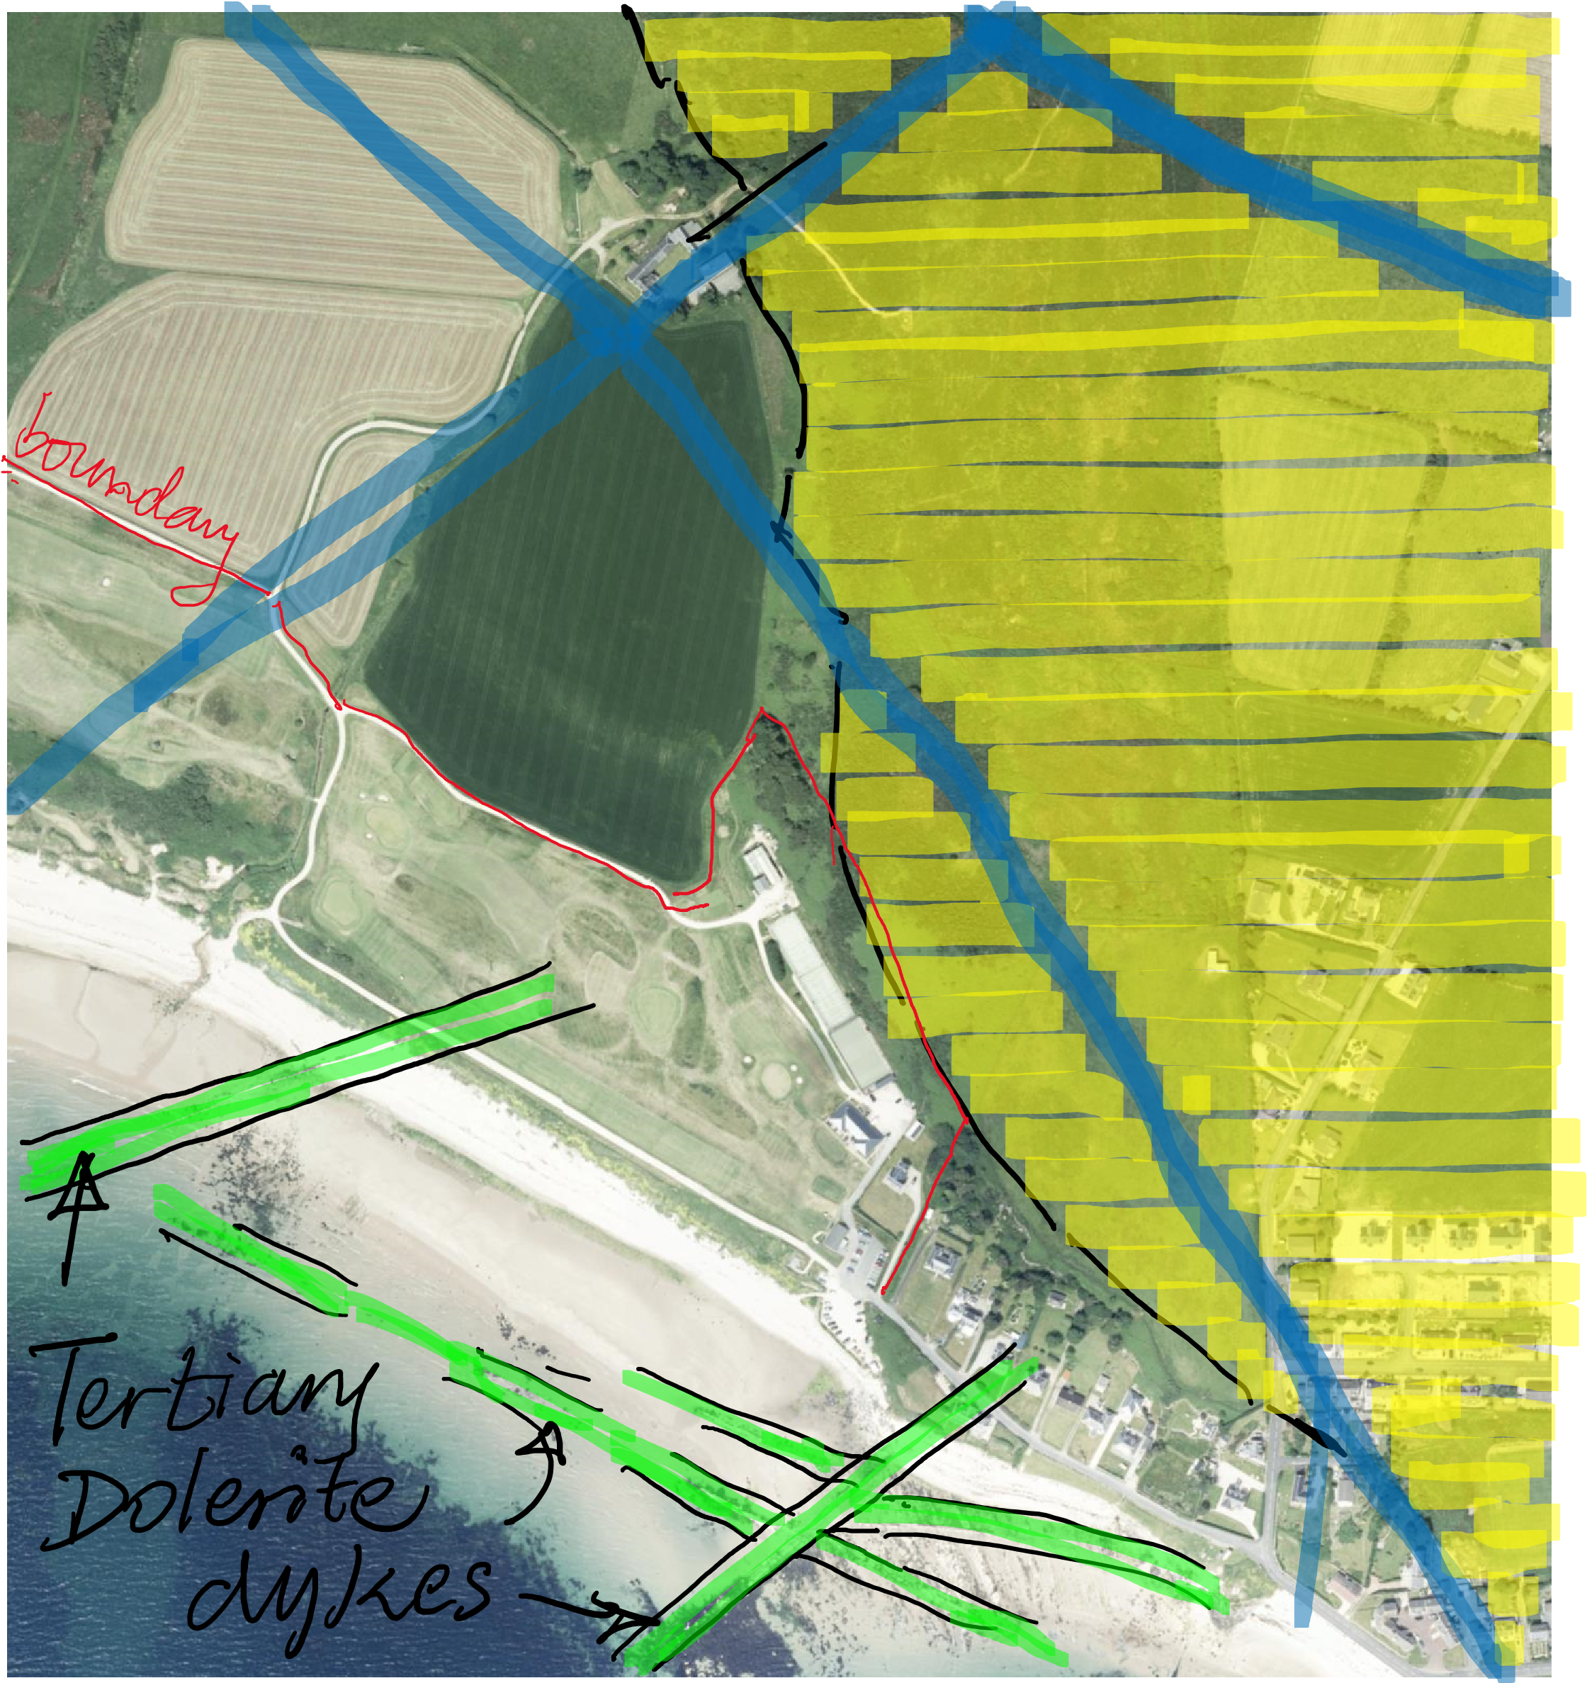

GOLF COURSE - WEST DETAIL 1
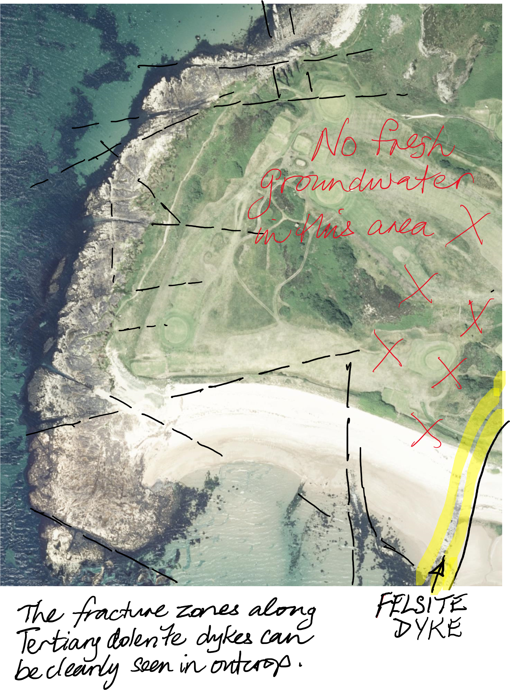

- WEST DETAIL 2
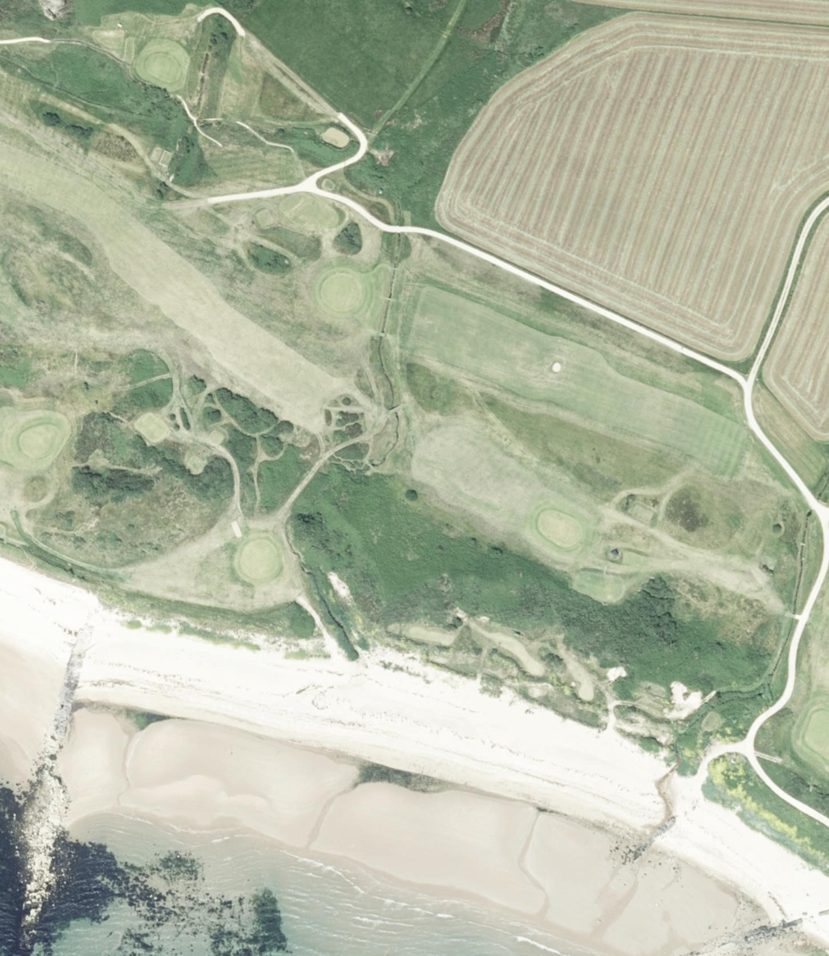

BH
-
2

BH
-
1

BH
-
3

– EAST DETAIL 1

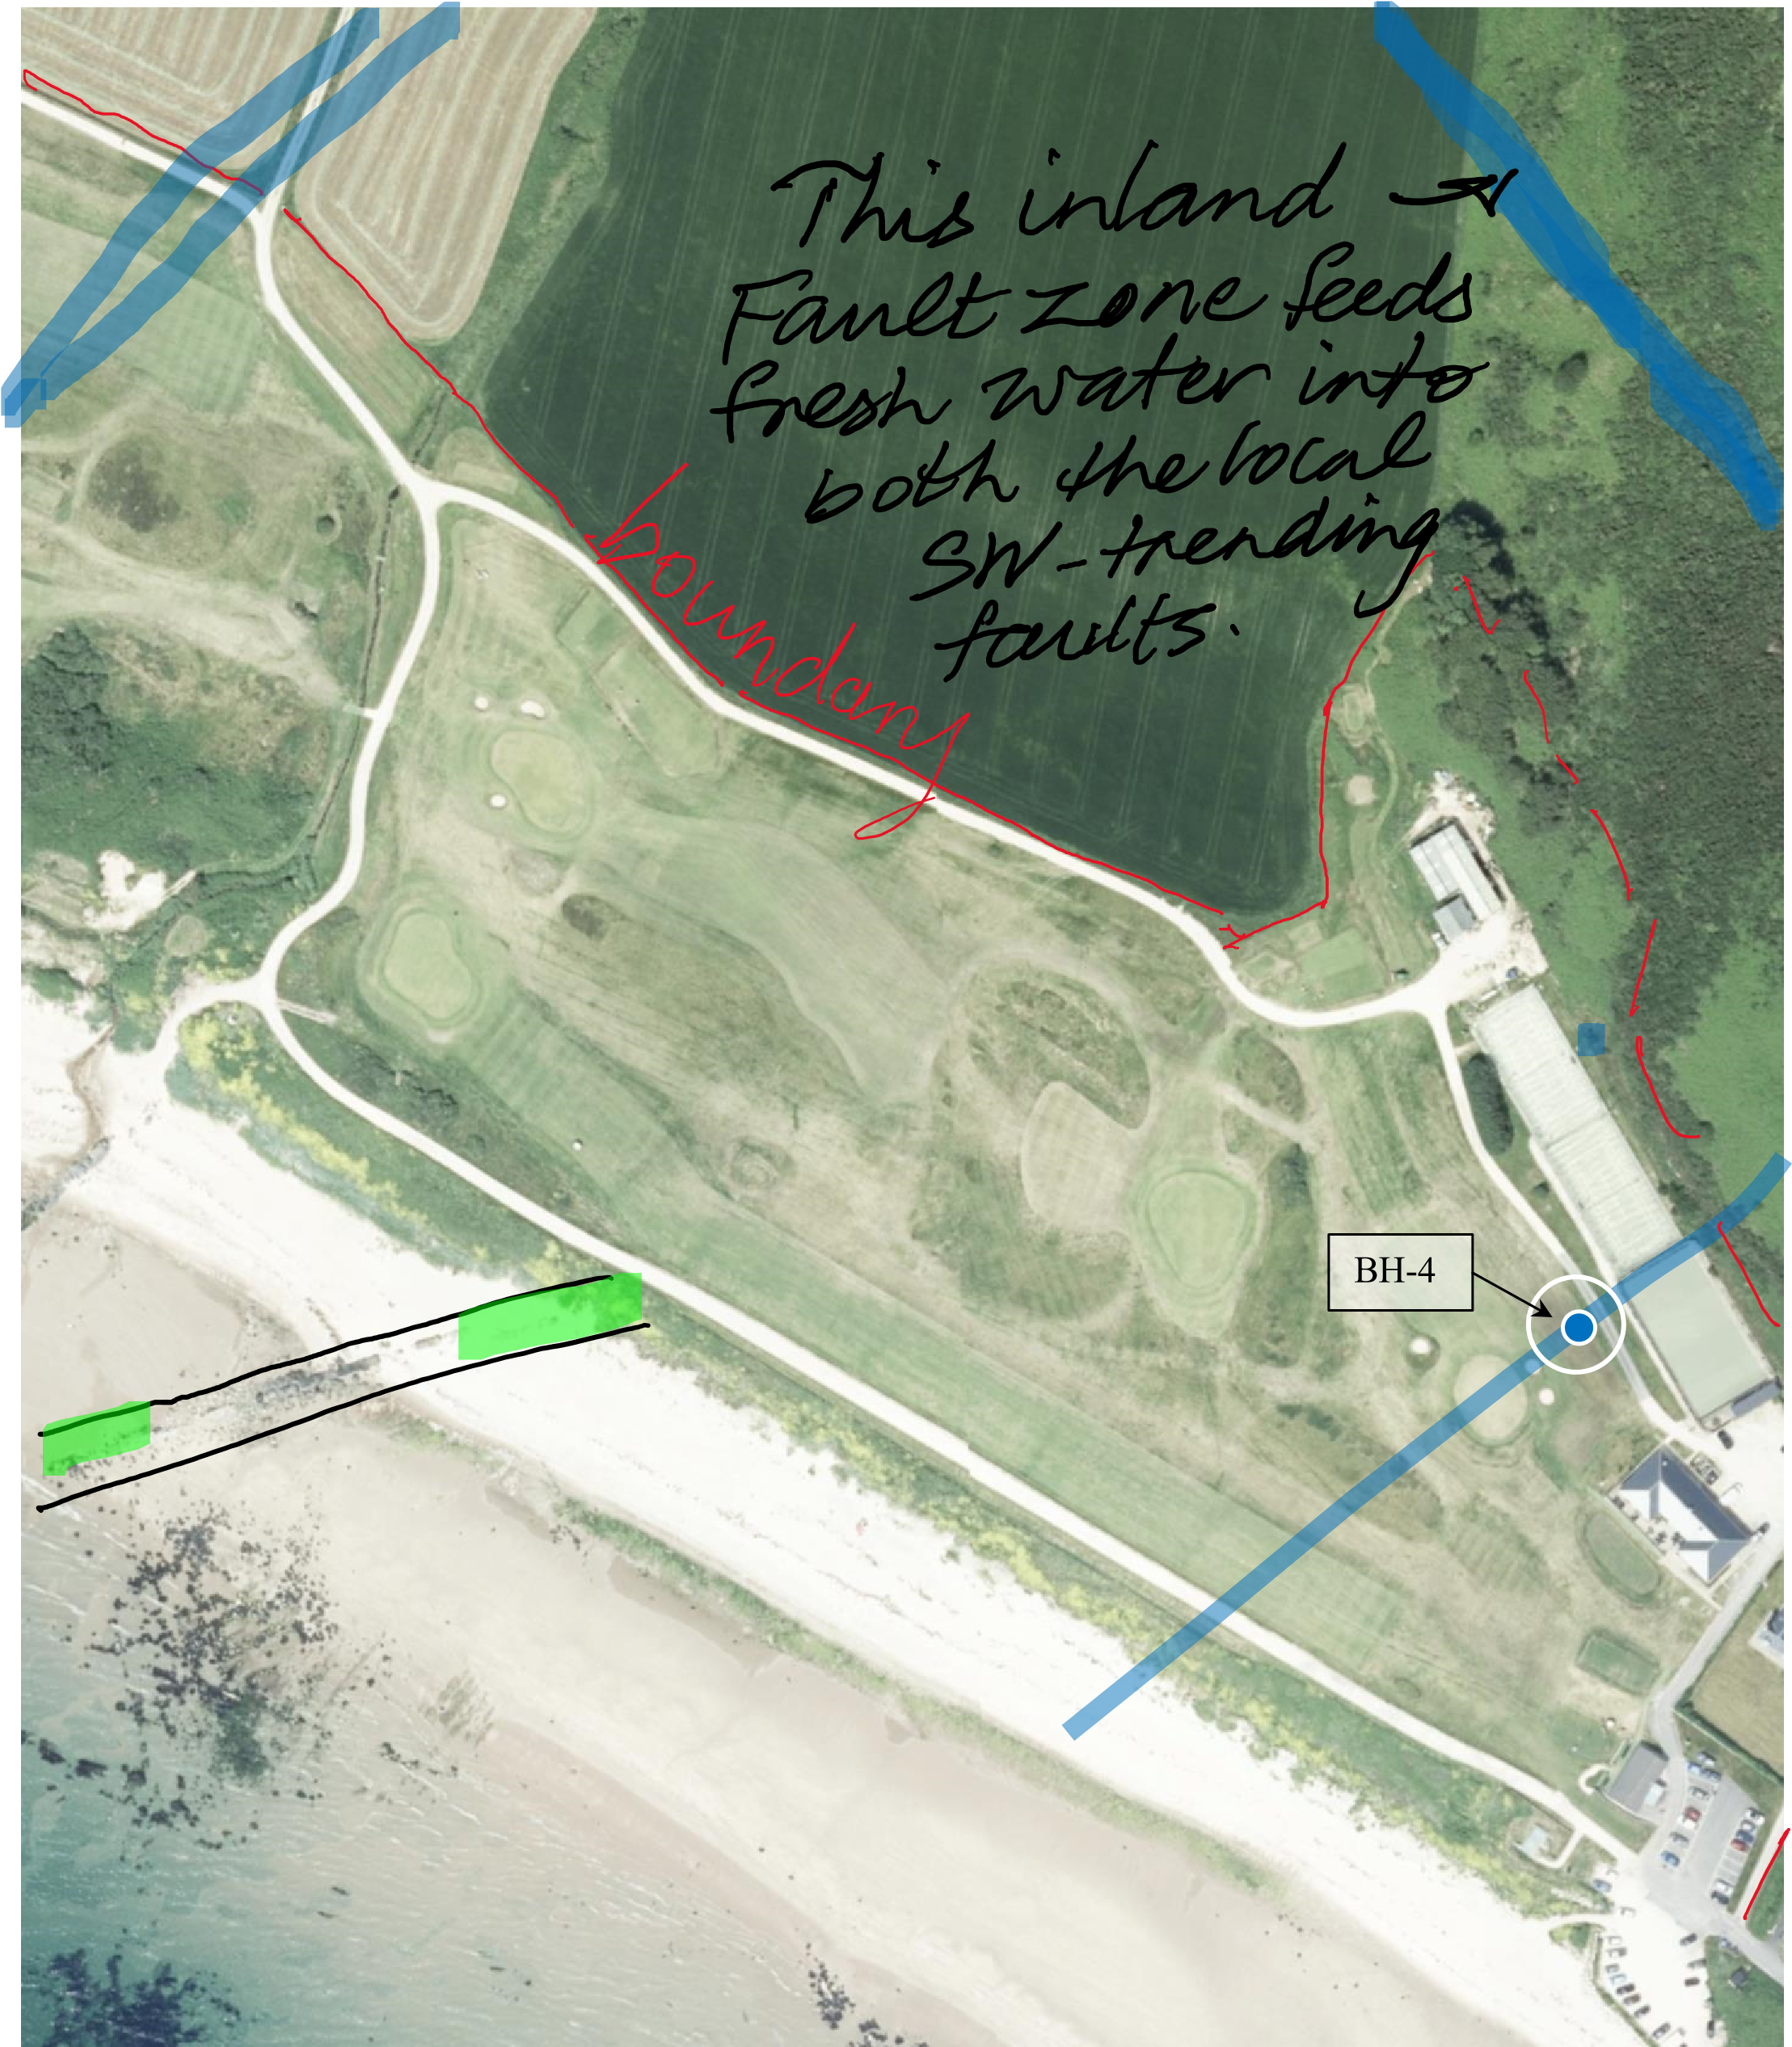

- EAST DETAIL 2
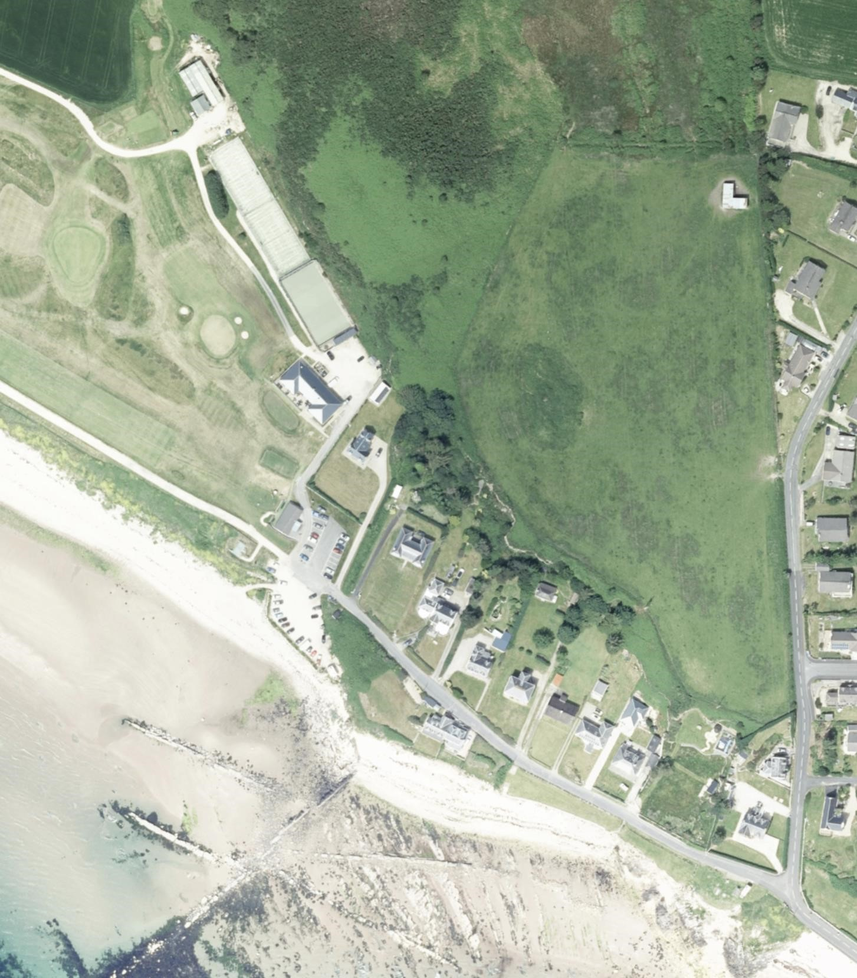

GOLF COURSE - WEST DETAIL 2(a)

BH
-
2

BH
-
1

BH
-
3

GOLF COURSE – EAST DETAIL 1(a)

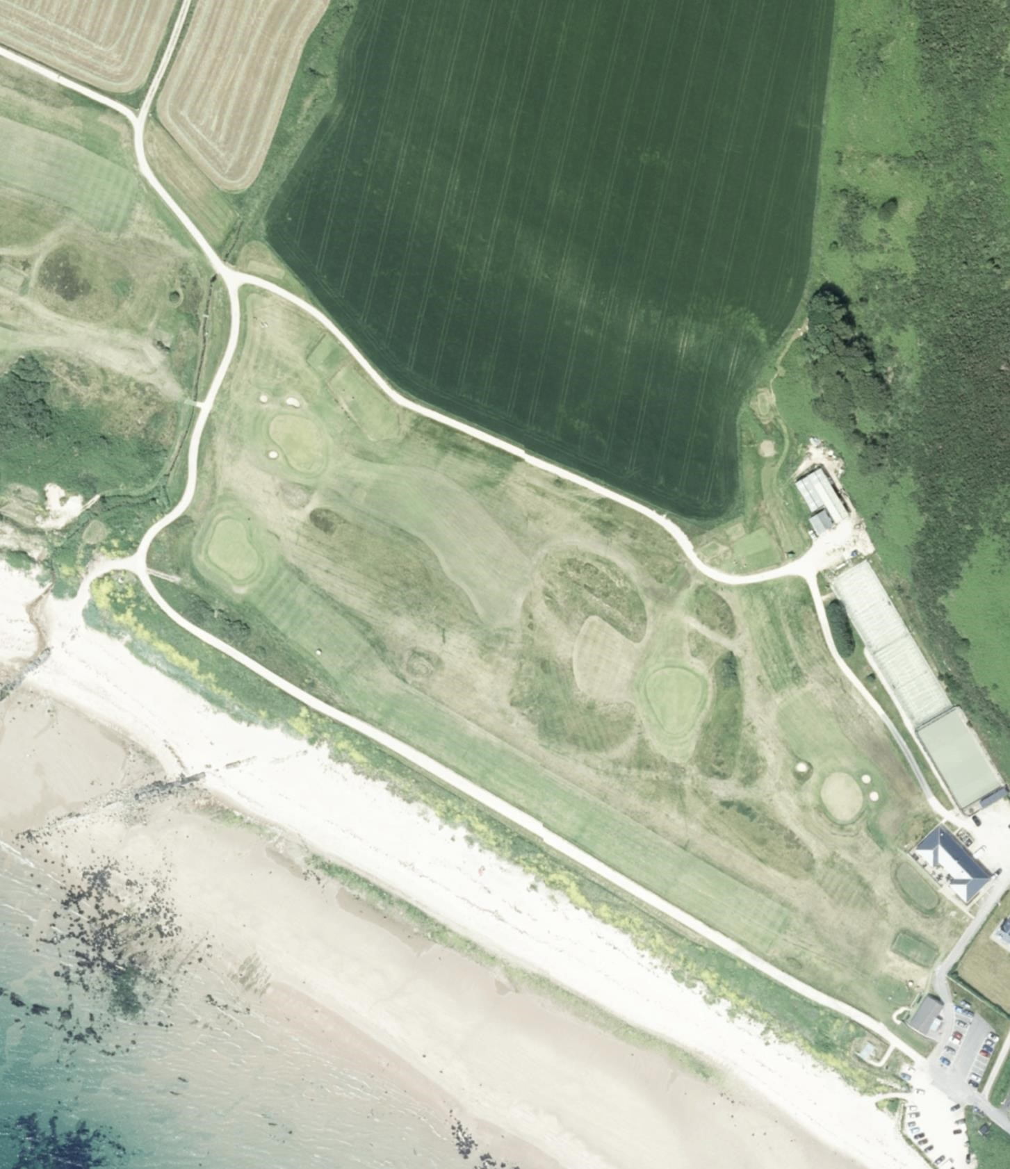

BH
-
4

FINDINGS OF THE GEODIVINING FIELD SURVEY:

Site accessibility for drilling at Shiskine Golf and Tennis Club, Blackwaterfoot, Isle of Arran KA27 8HA is via the main entrance to the club car park following the road through the public car park and straight on following the track to the Drumadoon Farm, once you turn away from the beach towards the north the track splits at the entrance to the Farm.

BH-1 and BH-2 are directly on the left of the track with BH-3 up on the rise between the two fairways running parallel with the track down the course. BH-4 is back towards the club house following the track away from the coast passing the greenkeeper’s sheds untill you arrive at the tennis courts on the left. The marker is between the track and the final green.

BH-1 is on gently sloping grassland, firm ground, close to the entrance gates to the farm and conveniently close to the track that runs out from the green keeping sheds. The location was marked directly at the drilling location with a marker post. The Club Manager was informed of the location and it was suggected that they make a more permanent marker so it doesn’t get removed by golfers before the drilling can commence for all 4 locations. It might be prudent for the water diviner to be pressent when the drilling company arrive to ensure they set up directly on the marked location.

BH-2 is also on gently sloping grassland close to BH-1 just a little bit further down the same track and is clearly visible from BH-1. Both are easily accessible for the drilling rig as they are in the rough cut grass just off the access track. Again it might be prudent for the water diviner to be pressent when the drilling company arrive to ensure they set up directly on the marked location.

BH-3 is on more sloping ground up the bank and within the rough ground between two fairways not far from the wooden hut on the hill. Access would be directly the same as BH-1 and BH-2 but then driving up the slope towards the sea, being carefull not to damage the fairway. The head green keeper will assist and perhaps will be able to show a route that does not involve fine turf areas. Again it might be prudent for the water diviner to be pressent when the drilling company arrive to ensure they set up directly on the marked location.

BH-4 is close to the track directly at the club house and tennis courts on gently sloping grassland, firm underfoot. The location was marked directly at the drilling location with a marker post. Again it might be prudent for the water diviner to be pressent when the drilling company arrive to ensure they set up directly on the marked location.

Geodivining survey work on site confirmed four potential borehole locations on good fractures within the area, one directly on a junction of two faults with the others on individual confirmed fault lines from the geological mapping. They are well away from the drainage and sewage outfalls from the Club Buildings, but
BH-4 is close to existing buried services including the water main from the club house to green keepers’ facility and possibly the power lines to the sheds and the tennis courts. The power can be extended with the new water transfer pipe to any of the locations from the source, but BH-1 is the closest. The BH-3 is remote from the current services but not too far to make it a suitable location. The aerial image and remote sensory work indicated the structures which were confirmed on site by divining. The pictures show the marking out with the table below containing the full details.

The location at BH-1 and BH-2 can be moved along the structure which is shown on the pictures should there be a need to be further away from the track or fairway lines, but I would recommend that Phil or Doug are there to align the rig with the correct location if that is the case.

Exact Locations were staked on site with white PVC pipes and photographs taken with GPS information taken from an iPhone. Casing Depths (into bedrock) and the potential Productive Depth Ranges are estimated, and finally the Potential Sustainable Yields are also estimated using ‘virtual borehole’ Geodivining techniques, with the following results.
Location | Grid Reference | Estimated Casing Depth | Estimated Productive Depth Range | Estimated Potential Sustainable Yield
BH-1 | NR 88838 28857 Staked Exactly | 16 - 17m | 29 - 85m | At 70m – 2,398 gal/hr  10.9 m³/hr
BH-2 | NR 88828 28862 Staked Exactly | 16 - 17m | 23 – 80m | At 65m – 2,332gal/hr  10.6 m³/hr
BH-3 | NR 88777 28819 Staked Exactly | 16 - 17m | 23 – 80m | At 65m – 2,926gal/hr  13.3 m³/hr
BH-4 | NR 89148 28580 Staked Exactly | 15 - 16m | 23 – 81m | At 65m – 1,166gal/hr  5.3 m³/hr

GENERAL DRILLING RECOMMENDATIONS:

In a conventional approach to risk management, where outcomes are uncertain, exploratory costs can be reduced by small-diameter test-hole drilling to prove a source before going in again with a full-sized abstraction well, however, in our experience the small diameter test holes produce much less water because yield is in proportion to their diameter and is also restricted by the displacement volume of drill pipes in the hole, such that one can only derive an approximate likely yield from a scaled up borehole.

Drilling twice costs more and we find, with the high reliability of Geodivining locations, that it is usually best to go straight in with the full-size abstraction well to directly measure and develop the full yield potential, to drill two 190mm wells at BH-1 and BH-2 to develop a 20m³/hr water supply, which is more than adequate for the purpose intended and would supply a surplus amount of water for future development at the property. It might be possible after designing the irrigation system that a smaller flow of the 13.3m³ might be sufficient and thus drilling one 279mm well at BH-3 would be sufficient.

PHOTOGRAPHS:

BH-1 Marking out and location

BH-1 Below are the details of the location closet to the gates of the farm

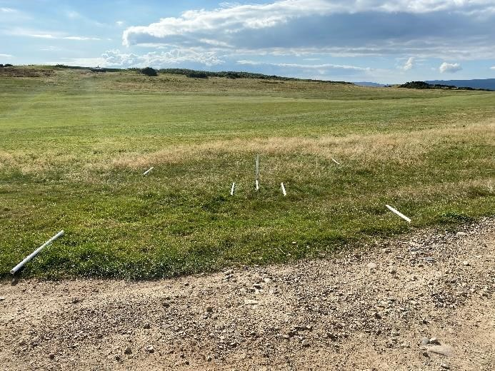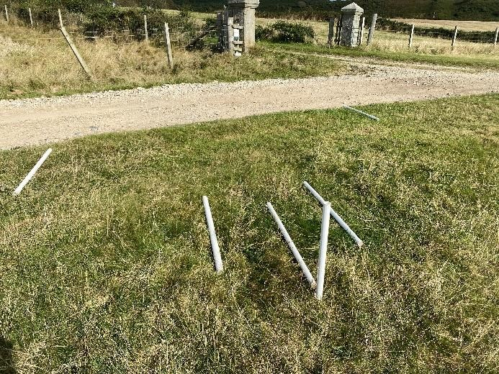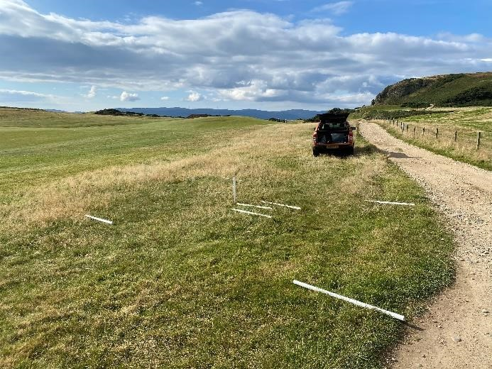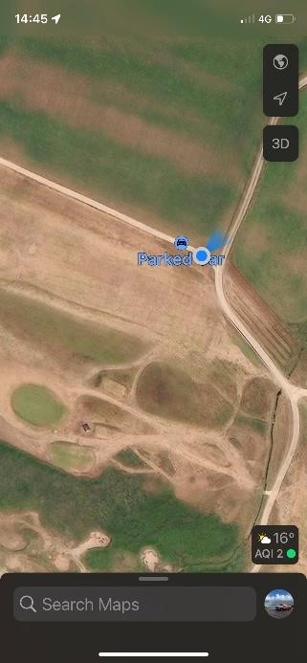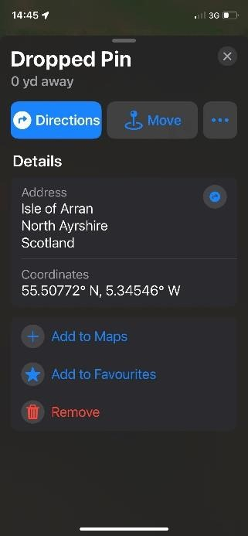

BH
-
1

BH
-
1

BH
-
1

BH-1 details of the location marked and the blue dot for reference

BH-2 Marking out

BH-2 Below are the details of the location furthest from the gates of the farm

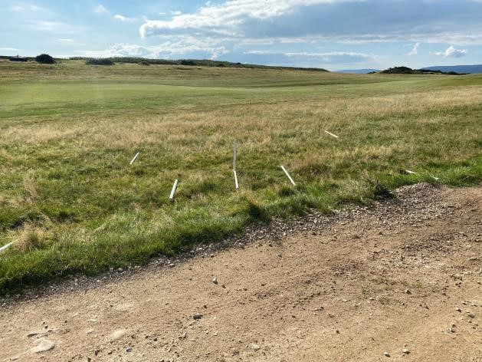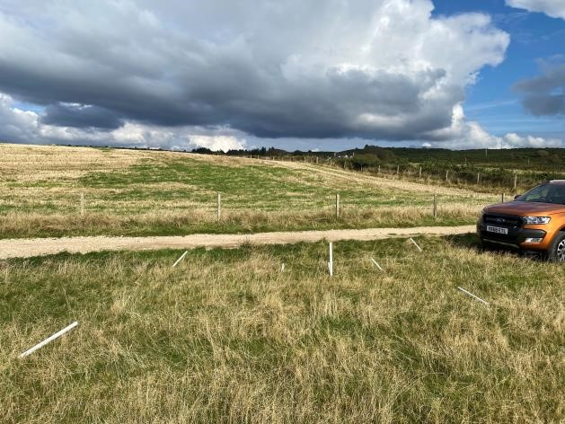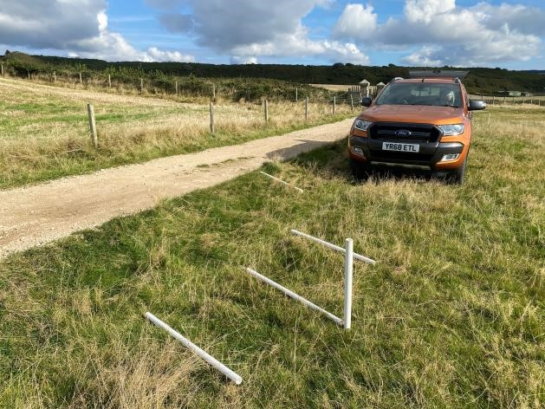

BH
-
2

BH
-
2

BH
-
2

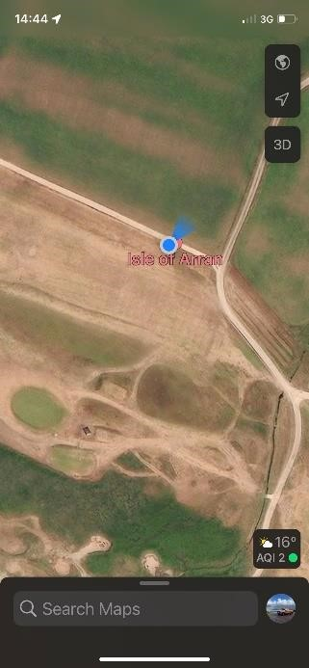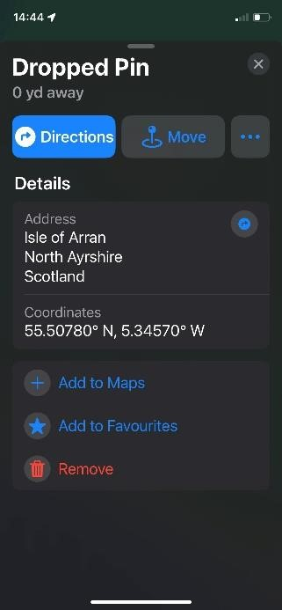

BH-2 Details of the location marked and the blue dot for reference

BH-3 Marking out

BH-3 Below are the details of the location up on the ridge parallel with the track
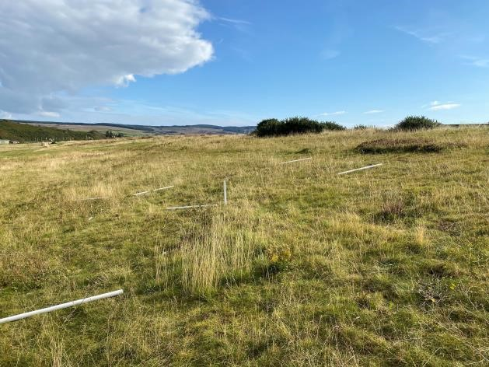
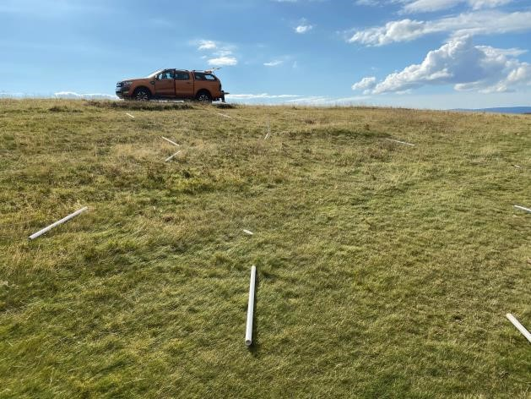
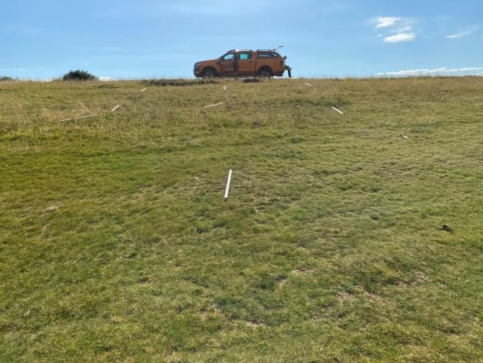
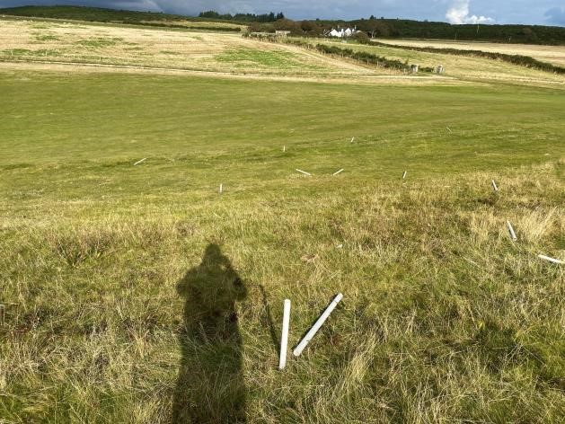
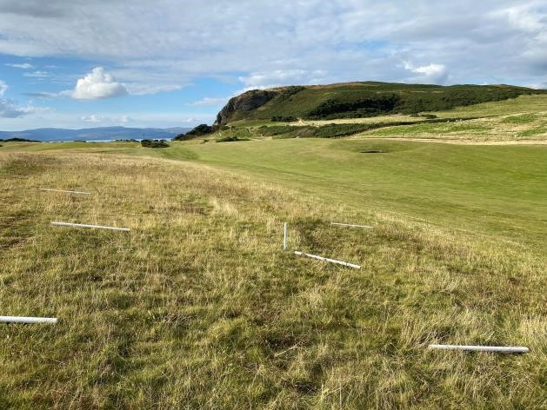
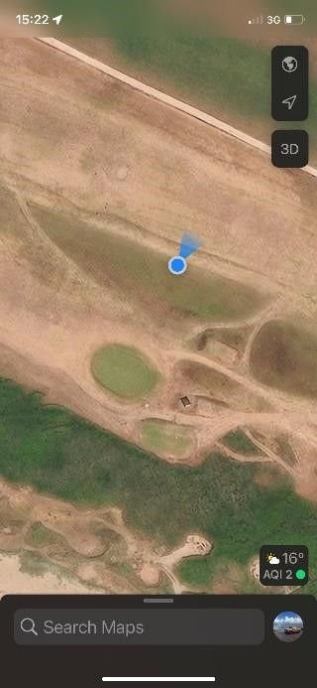
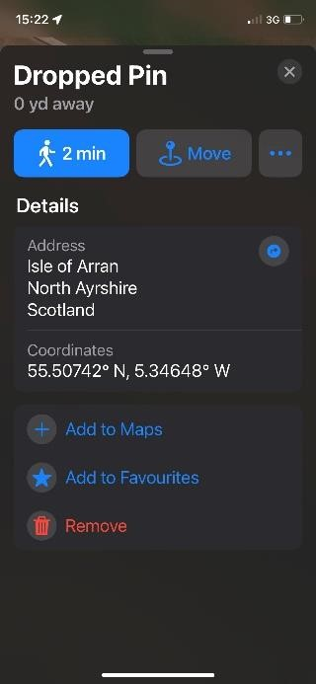
BH
-
3

BH
-
3

BH
-
3

BH
-
3

BH
-
3

BH-3 Details of the location marked and the blue dot for reference

BH-4 Marking out

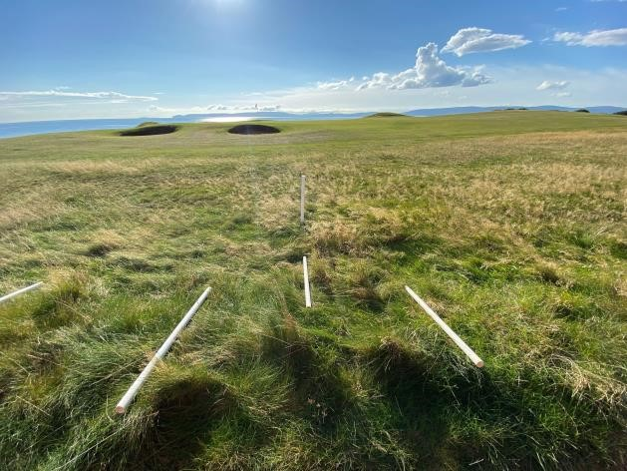
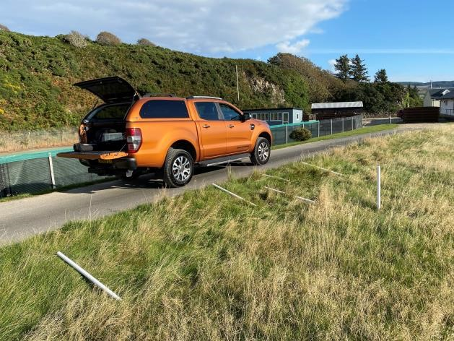
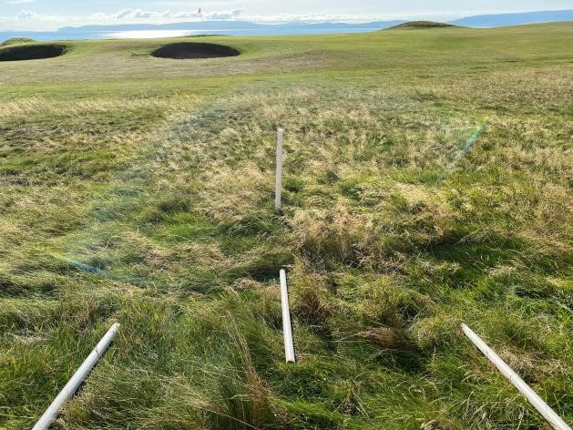
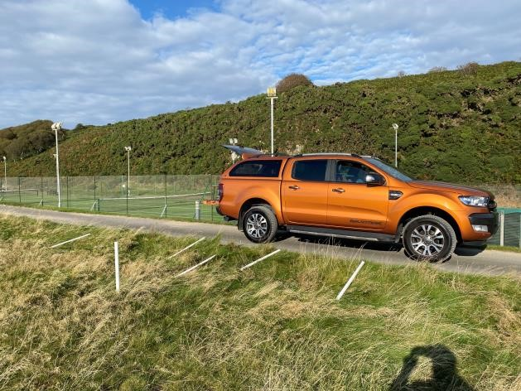
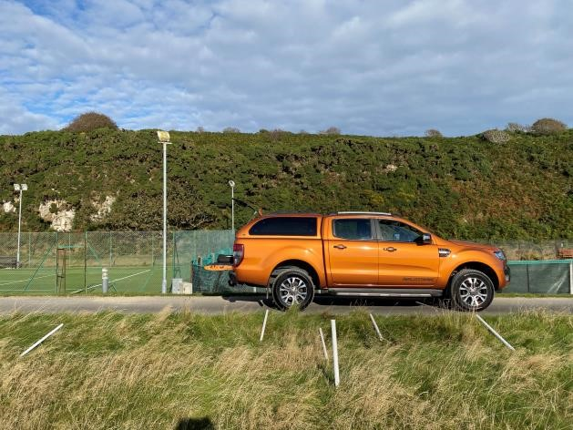
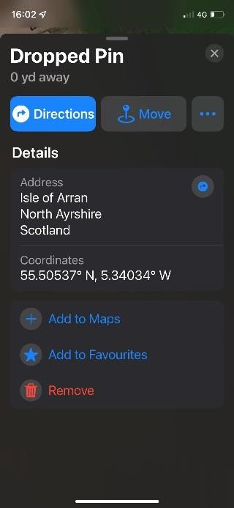
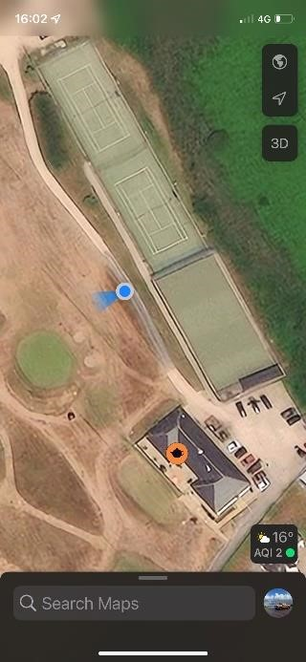
BH-4 Below are the details of the location close to the track by the tennis courts
BH
-
4

BH
-
4

BH
-
4

BH
-
4

BH
-
4

BH-4 Details of the location marked and the blue dot for reference

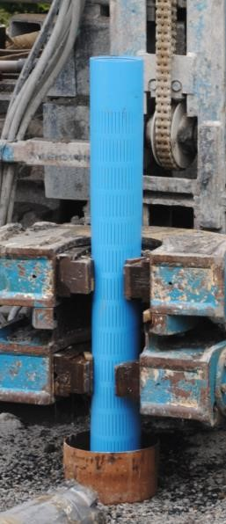
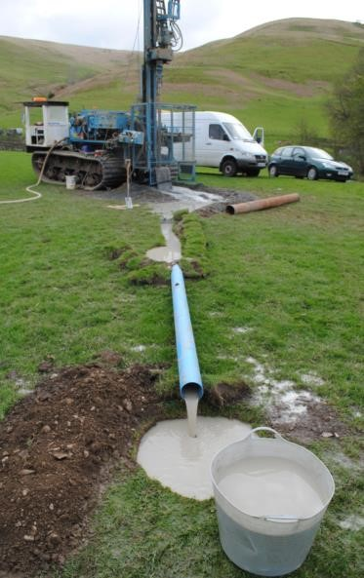
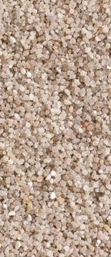
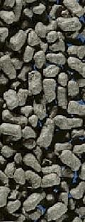
DRILLING SPECIFICATIONS

For each borehole, using 220mm or 324mm sacrificial casing method, secure the upper part of the borehole through superficial soil, subsoil and weathered rock to estimated casing depth to effect an adequate seat into firm bedrock.
Change bit to 190mm or 279mm diameter rock bit and commence drilling open hole in the bedrock (see geological description), to at least the estimated optimum depth, or deeper as may be necessary to achieve peak yield measured off the drill.

The first water strike and flow measurements at intervals thereafter should be measured and logged (top right) and once an ideal flow or at least the minimum required flow is assured, ideally with a comfortable excess margin, at which point a decision can be made as to when to stop drilling and clean the borehole.
Once drilling is completed the borehole should be flushed clean in preparation for the borehole lining tube / well-screen and filter-pack installation (bottom right) and subsequent test pumping.

Good quality well-screen / lining tube with filter medium in the annulus between the tube and the rock prevents any movement of loose rock in the fractured zone and improves the stability and longevity of the working borehole. It also provides a pre-filter, which traps any loose sand grains and improves longevity of the pump. Appropriate sized Boode well-screen (126 x 113mm, 140 x 126mm, or 225 x 199mm) with 1mm filter slots (right) installed with high quality graded triple-washed silica filter medium (bottom left) will provide optimum performance and longevity.
The gravel filter medium fills the annular space in the productive screened portion of the borehole lining up to a level within bedrock and a few metres below the foot of the steel casing (according to actual drilling findings).
The tube above this section is solid-walled up to ground level and this part of the borehole annulus is filled with bentonite cement pellets (above left), which swell to form a watertight sanitary seal encapsulating the plastic lining, with bentonite cement grout right to the top, isolating it from the mild steel sacrificial casing and preventing any risk of contamination from shallow water ingress from the soil and subsoil layers.
This method of lining installation is efficient and economical, providing good quality seals with flexibility in design to suit ground conditions and aquifer characteristics, compared to time consuming and inflexible cement grouting methods.
UNCERTAINTY RISK.

The risk, of drilling a dry or very low yield hole within the target depth range, or of having to drill to excessive depth (more than 100m) to achieve the minimum yield requirement is quite high at random locations, but on Geodivining locations it is reduced to the minimum level (under 10%).
All drilling operations are exploratory to some degree and satisfactory results cannot be absolutely guaranteed, but Geodivining does optimise the chances of success at economical drilling depths and achieves unrivalled overall first strike success rates for exceptionally high yields.

It is possible that the yield potential could be overestimated and that deeper or additional borehole drilling may be necessary just to secure the minimum required water supply, but based on statistical appreciation of thousands of results from other Geodivining Surveys it is most likely the yield from the first borehole will match or exceed the surveyed estimate and should exceed the minimum target yield in the intermediate depth range without necessitating drilling to the full depth of the productive zone.

OPTIONAL PROJECT MANAGEMENT & BOREHOLE LOGGING SERVICES:

For large or specialised commercial groundwater developments boreholes must always be properly logged and measured, requiring the project geologist to be on site managing the work from start to finish, but for domestic water supplies and most agricultural water supplies this service is not essential and is offered as an optional extra if you want that level of confidence and peace of mind knowing we are giving you the best possible chance of a successful and optimal water supply development…

The full borehole logging and testing service that Geodivining International provides (see guide), fully facilitates proper environmental compliance and detailed recording of the geological and flow logs as the borehole is drilled. Typically, just 1 or 2 days is required for the borehole supervision and logging of each borehole, and an extra day for a brief drilling report.
Having the project geologist supervising the work also provides for on-the-spot decisions on when to stop or continue drilling, dealing with possible unexpected ground conditions, and optimal borehole lining design and installation. A ‘Full Report’ (see Survey Guide) may contain all these details.

YIELD TESTING AND WATER QUALITY ANALYSIS:

Work to install a temporary pump to test the productivity and quality of the new water supply should be included in the quote from the drilling contractors, and this is always recommended before installing a permanent pump and wellhead.

I look forward to seeing this development drilled and completed sometime this year.
In the meantime, please don't hesitate to call about any further queries you may have. I am generally available on the mobile phone 07828 417841.

Yours Sincerely,

Doug Bates, BSc(geol), FGSA, MGA, MIAH, MSEG, (Proprietor, Geodivining International) Consulting Exploration Geologist & Professional Diviner for Water, Hydrocarbons, and Minerals.

DISCLAIMER:- The use of Geodivining methods of water location and assessment together with geological research and observation will generally achieve optimum productivity in all fields of exploration; however, although Geodivining International maintains a high success rate, we do not undertake to guarantee a successful outcome, nor do we accept any liability for any damage or cost incurred by development work carried out on the basis of our recommendations whether successful or unsuccessful.

